COMPUTERIZED ACCOUNTS WITH QUICKBOOKS PRO

TRAINING NOTES

Introduction to Computerized Accounts

Getting Started with QuickBooks
In this section, you will learn how to:
- Setup Quickbooks for your company
- Convert data from Quicken
- Create a new company file
Understanding QuickBooks Accounting
QuickBooks automates double-entry accounting, tracking transactions throughout the accounting cycle from creating purchase orders and receiving items to selling goods and services and depositing payments.
QuickBooks uses accounts to group financial data by purpose. Balance sheet accounts track assets and liabilities: asset accounts track what your company owns, including cash, inventory, equipment, buildings and money owed by your customers; and liability accounts track your company's debts, including loans, credit card debt, taxes and accounts payable—what you owe vendors. Equity accounts track earnings retained for business growth and investment into the company by its owners. As you enter purchase orders, bills, invoices and payments into QuickBooks, you associate each of these with a particular asset, liability or equity account.
This is the fundamental basis for QuickBooks' automated balance sheet accounting process. A balance sheet describes the financial health of your company and is calculated based on the simple formula: Assets=Liabilities+Equity. Much of QuickBooks' power comes from its ability to track complex, inter-related transactions as they contribute to this formula. As long as you keep complete records and associate the transactions you enter with the appropriate accounts, QuickBooks will handle much of the complexity of business accounting for you.

Setting Up Your Business in QuickBooks
To create a new company file, open the File menu and select New company. This starts the EasyStep Interview, which guides you through the process of creating your company database:
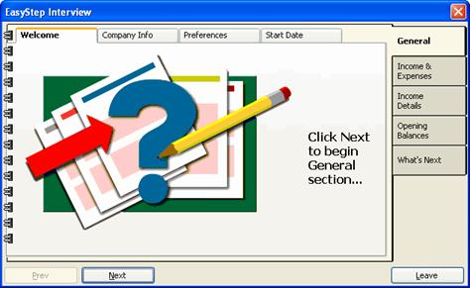
The setup process is divided into five stages, which are represented by tabs at the right of the interview screen. Each of these tabs is further divided into several sections, represented by tabs at the top of the screen. As you complete each stage of the interview a checkmark will appear on the appropriate tab.
Use the Next and Prev (Previous) buttons to move forward and backward through the interview. You can move backward to make changes to information you've already entered.
To begin the interview, click Next, and then click Next again.
Creating a New Company File
If you do not need to convert existing Quicken data, click Next in the EasyStep Interview to progress to the next screen. At this point, you can choose to skip the interview and enter your company information manually; however, using the EasyStep Interview is recommended, since it provides a great deal of information to help you make the correct choices for your particular company.
To complete the Welcome screens, click Next until you reach the Company Info tab:
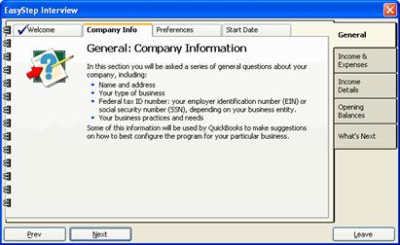
To enter your company information:
- Continue to click Next until the following screen appears:
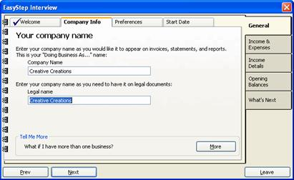
- Enter your company's DBA and Legal names.
- Click Next.
- Enter your company's general details:
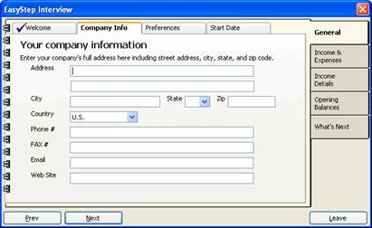
- Click Next.
- Enter your federal tax ID number and the first month of your income tax and fiscal years:
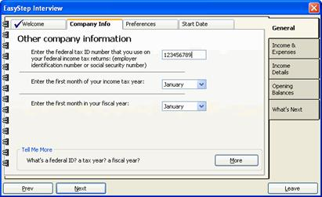
7. Click Next.
8. From the drop-down menu, select the tax form your company uses:
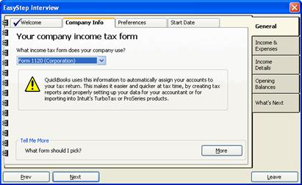
9. Click Next.
10. From the list, select the industry that best fits your type of business:
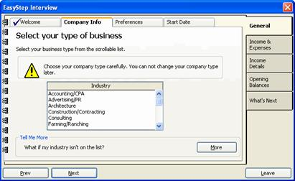
If you provide a service, select Service Business. Some of the options available to you later in the set up will depend on whether you've selected a service or product-based business.
If you don't see an industry that fits your business, select Other.
11. Click Next.
12. Continue to click Next until you're prompted to save your QuickBooks file:
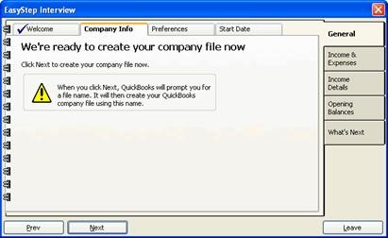
- Click Next to save the file.
- In the Filename for New Company dialog box, browse to the location where you want to save your QuickBooks file and click Save:
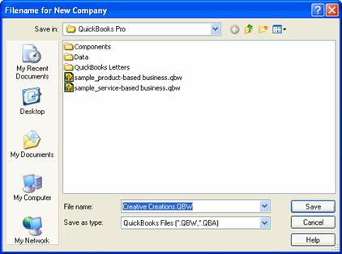
The main QuickBooks interface appears, with the name of your company in the title bar.
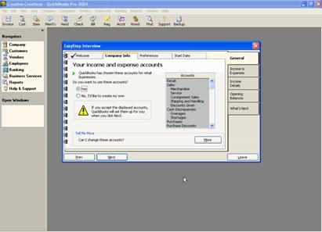
You're now prompted to set up your income and expenses accounts:
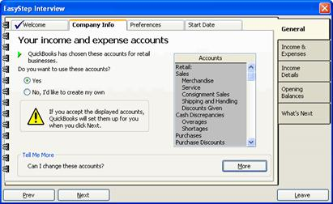
The Accounts list on the right side of the screen contains pre-defined accounts based on the type of business you selected earlier. For now, it's best to use the accounts QuickBooks has selected; you can always edit or delete them later, as well as add new accounts as necessary.
- Select Yes to accept the pre-defined chart of accounts, and then click Next.
- Enter the number of people in addition to yourself who should be able to access your QuickBooks company file:
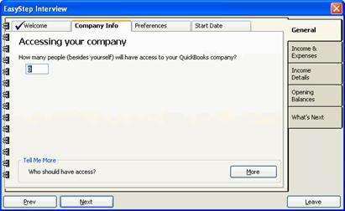
You should include in the number people who will need to enter data and run reports.
You will retain administrative access to the QuickBooks file. As the administrator, you'll be able to set access privileges for each of your users.
- Click Next.
- Enter an administrator name (such as Admin) and an administrative password:
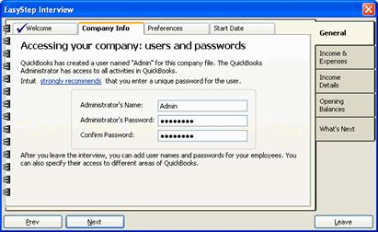
- Click Next.
This completes the Company Information tab.
- Click Next to proceed to the Preferences tab:
The Preferences screens let you turn on and off features such as sales tax, payroll and time tracking:
- Click Next until you reach the Sales tax screen:
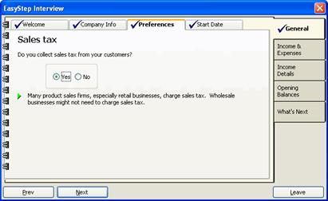
- If you collect sales tax from customers, select Yes; otherwise, select No.
- Click Next.
- The next screen asks whether you use single or multiple sales tax rates. If you use a single tax rate, you will be prompted to enter tax and agency information on the next screen; if you use multiple sales tax rates or pay sales tax to multiple tax agencies, you will have to set up sales tax when you've finished the interview.
Select the appropriate option and click Next.
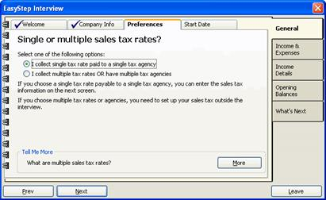
- If you selected a single tax rate, enter your sales tax information and click Next:
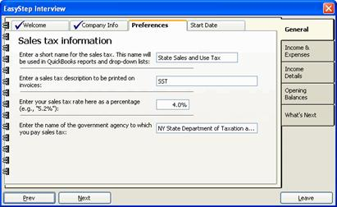
Otherwise, click Next to proceed to the next step:
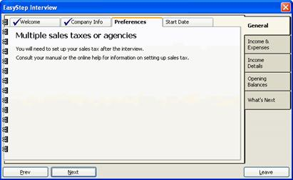
- Select a default invoice format. When you select a format, a preview of the invoice appears to the right:
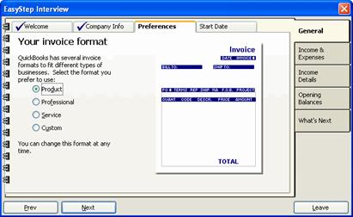
- Click Next.
- The next screen lets you enable payroll functionality in QuickBooks:
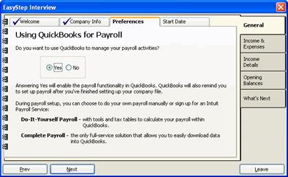
If you want to use QuickBooks to manage payroll, select Yes; otherwise, select No.
If you select Yes, you'll be able to set up your payroll activities after you've completed the interview.
- Click Next.
- If you prepare estimates for customers, select Yes in the next screen; otherwise, select No:
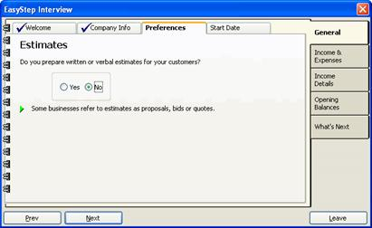
- Click Next.
- If you want to track time spent on projects, select Yes; otherwise, select No:
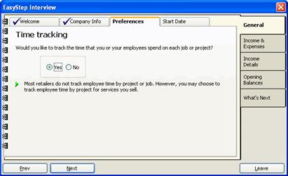
- Click Next.
- The next screen lets you enable the use of classes. Classes let you break down your business by transactions, so that you can track income and expenses by the various segments of your business, such as a retail location, a department or a particular enterprise. This lets you more easily determine profit and loss for those parts of your business you want to keep an eye on.
If you select Yes, you'll be able to set up classes when you've completed the interview.
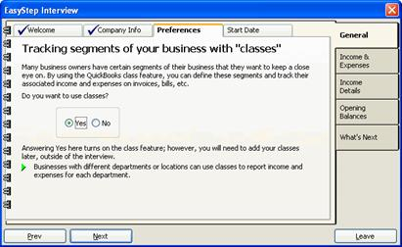
- Click Next.
- Choose how you want to handle bills and payments—by entering checks as you write them, or by entering bills, which you'll pay as they become due:
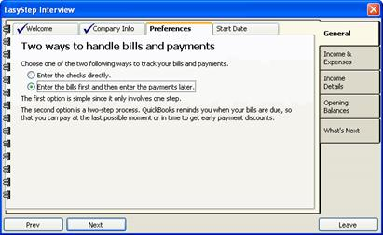
- Click Next.
- Choose when you want QuickBooks task reminders to appear—at start up, when you ask for it, or rarely:
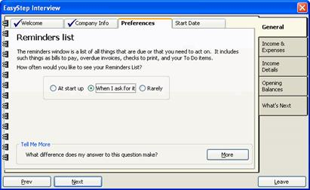
- Click Next.
- The next screen lets you specify whether you use cash-based or accrual-based reporting. Cash-based reporting tracks income and expenses as money is received and sent; accrual-based reporting tracks income and expenses based on invoices and bills.
Accrual-based reporting lets you more effectively track expenses generated in producing sales, and results in a more accurate picture of your company's overall financial health. Unless you pay all your bills as soon as you receive them and carry no accounts receivable (that is, you sell all your inventory for cash or credit), you should choose Accrual-based reports. Even if you use cash-based reporting when you file taxes, you can still select accrual-based reporting here and generate cash reports from QuickBooks when you need them.
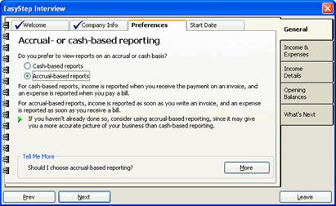
- Click Next.
This completes the Preferences tab.
- Click Next to enter your company's start date information:
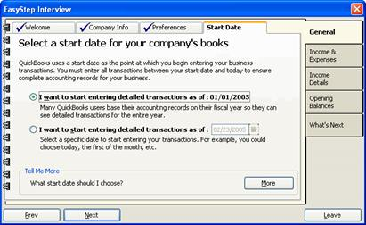
Unless your company is brand new, you'll need to enter historical transactions, so enter a start date as close to the beginning of your fiscal year as possible.
- Select either the start of your fiscal year (the first option) or another date (the section option) and click Next.
This completes the steps for the General section of the interview.
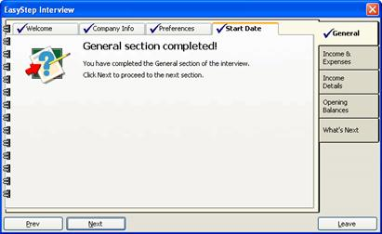

The next stage of the interview lets you set up your income and expense accounts. Continue to click Next until you reach the beginning of the Income Accounts screens:
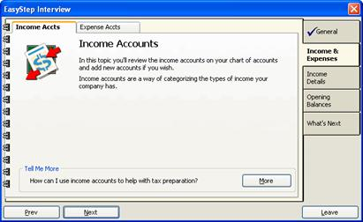
Click Next again to view a list of the income accounts you selected when entering your general company information.
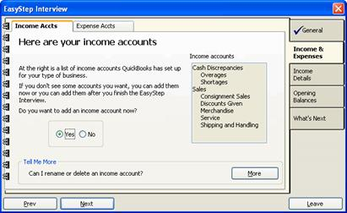
Here, you can add accounts as necessary:
- With Yes selected, click Next.
- Enter a name for the account and select the income tax form line associated with the type of account:
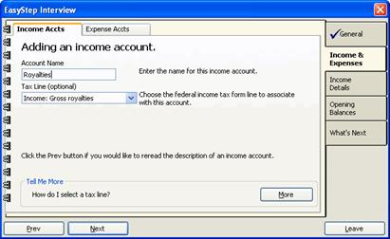
- Click Next.
The new account now appears in the income account list:
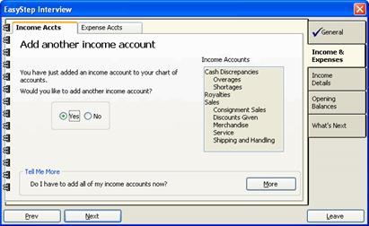
- To add another account, repeat the above steps.
- When you've finished adding income accounts, select No and click Next.
This completes the Income Accounts screens.
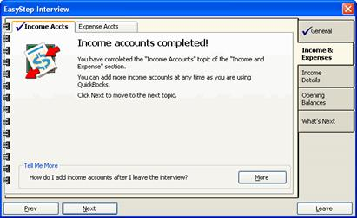
- Click Next to proceed to the Expense Accounts screens:
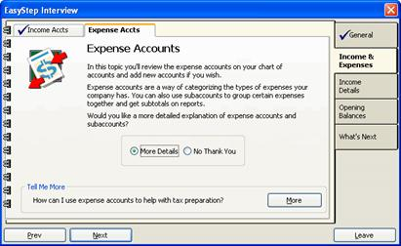
Expense accounts let you track the money your company spends in various areas such as equipment rental, office supplies, utilities and travel. Expense accounts can be subdivided into subaccounts, which make it easier to view and analyze exactly where money is being spent.
If you want to learn more about using expense accounts in QuickBooks, select More Details and click Next to proceed through the informational screens. Otherwise, select No Thank You and click Next.
The next screen lists the expense accounts you selected when entering your general company information:
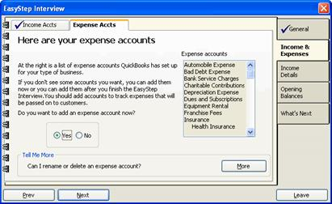
Here, you can add accounts as necessary:
- With Yes selected, click Next.
- Enter a name for the account and select the tax form line associated with the type of account:
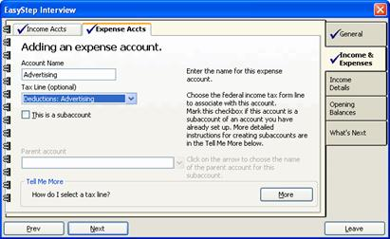
- If you want to make this account a subaccount of an existing expense account, check the box labeled This is a subaccount.
- Under Parent account, select the parent account for the new subaccount you're creating:
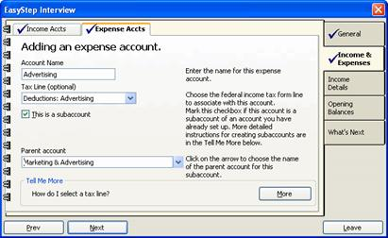
- Click Next.
- The new account now appears in the expense account list. To add another account, repeat the above steps.
- When you've finished adding expense accounts, select No and click Next.
This completes the Income & Expense section of the interview.
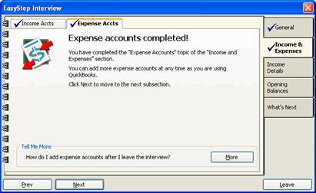

Click Next to proceed to the Income Details section.
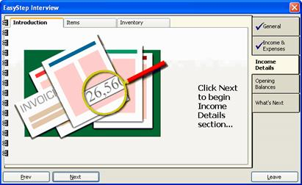
QuickBooks uses the information you provide about your income to determine which income and accounts receivable features to use. Accounts receivable refers to the money owed to you for unpaid sales. This feature in QuickBooks lets you track money owed and the dates payments are or were due.
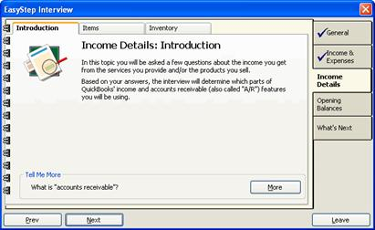
To enter your income details:
- Click Next to progress to the Receipt of payment screen:
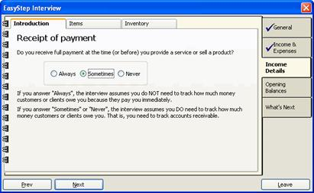
- Select the option that best describes when you receive payment for your goods or services.
- Click Next.
- If you want to produce monthly statements for customers, select Yes; otherwise, select No.
- Click Next.
- Click Next again to proceed to the Items screen:
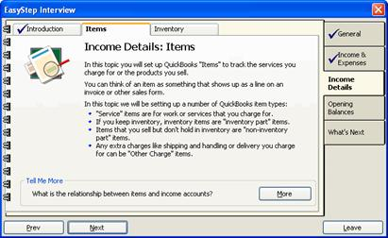
The Items screens prompt you to define the types of items you'll use to track the goods and services you sell. Items generally reflect line items on an invoice and are associated with a particular income account. When sales are recorded, items are posted to the income account and to accounts receivable.
To define items:
- Click Next to proceed to Service Items:
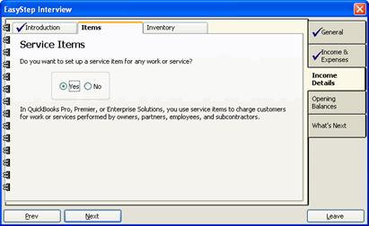
- If you want to set up items for services you provide, click Yes; otherwise, click No to proceed to Non-inventory Parts (Step 20, below).
- Click Next.
- If you selected Yes, the following screen appears:
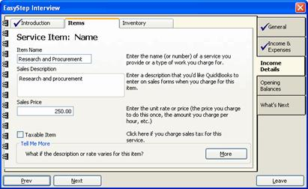
- Enter a name and description for the item.
- Enter a unit rate for the item. If the rate or price varies, you can either enter a default rate or 0. When creating invoices, you can adjust the price as necessary.
- If the item is taxable, check the Taxable Item box.
- Click Next.
- From the drop-down menu, select the income account to associate with the item:
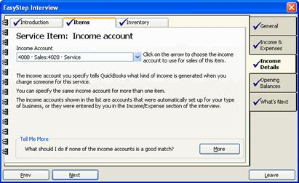
- Click Next.
- If the service is ever performed by a subcontractor, select Yes; otherwise, select No.
- Click Next.
- If you selected Yes, you're prompted to enter purchase information for the item:
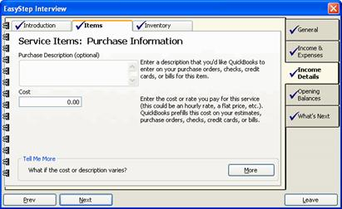
- Enter a purchase description and the cost you pay for the service.
- Click Next.
- Select the expense account to associate with the purchase:
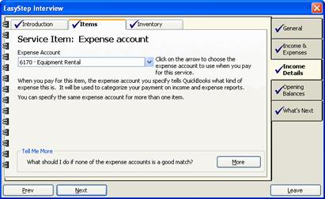
- Click Next.
- To set up another service item, select Yes and click Next. Repeat the above steps until you've finished setting up your service items.
- To proceed to non-inventory parts, select No and click Next:
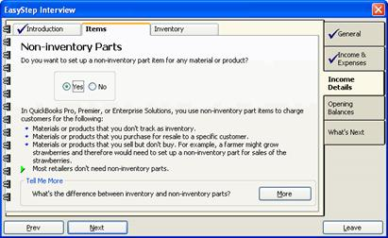
Inventory parts are items you keep in stock. Non-inventory parts are items you sell as soon as you buy. For inventory parts, QuickBooks tracks the quantity and value of your inventory; for non-inventory parts, QuickBooks only tracks what you've spent and received.
- To enter a non-inventory part, select Yes; otherwise, select No to proceed to Other Charges (Step 35, below).
- Click Next.
- If you selected Yes to enter a non-inventory part, the following screen prompts you to enter sales information for the part:
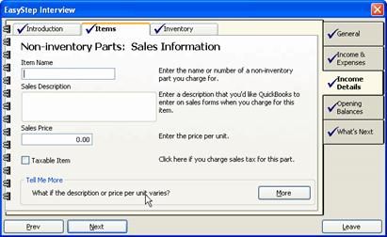
Enter an item name, description and sales price, and check the Taxable Item box if you charge sales tax for the item.
- Click Next.
- Select the income account to associate with the item.
- Click Next.
- If you ever purchase the item to sell to a specific customer, select Yes; otherwise, select No to add a new non-inventory part or to proceed to the next section.
- Click Next.
- If you selected Yes above, you're prompted to enter purchase information for the item:
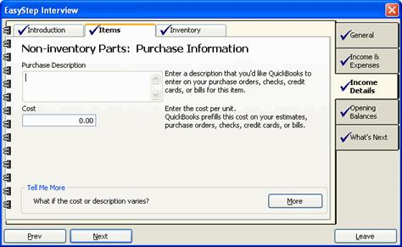
- Enter a purchase description and unit cost.
- Click Next.
- Select the expense account to associate with the item.
- Click Next.
- To set up another non-inventory part, select Yes and click Next. Repeat the above steps until you've finished setting up your non-inventory parts.
- To proceed to Other Charges, select No and click Next:
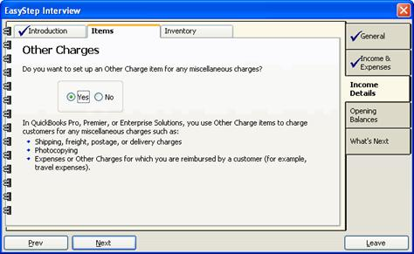
These screens let you set up items for miscellaneous charges such as shipping and handling or other expenses for which you're reimbursed by the customer.
- To enter an Other Charge item, select Yes; otherwise, select No to complete the Items section of the interview.
- Click Next.
- If you selected Yes, enter an item name, description and sales price:
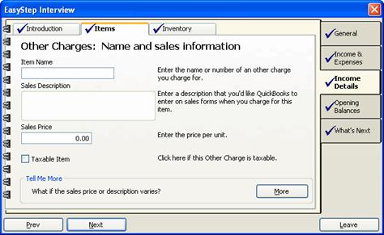
If you charge sales tax for the item, check the Taxable Item box.
- Click Next.
- Select an income account to associate with the item.
- Click Next.
- If this is an item for which you request reimbursement from the customer, select Yes; otherwise, select No.
- If you selected Yes above, you're prompted to enter purchase information for the item. Enter a purchase description and unit cost.
- Click Next.
- Select the expense account to associate with the item.
- Click Next.
- To set up another item, select Yes and click Next. Repeat the above steps until you've finished setting up your miscellaneous items.
- To complete the Items screens, select No and click Next:
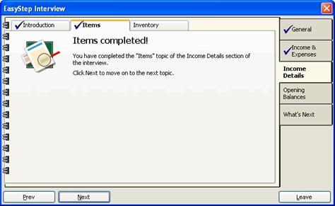
- Click Next again to proceed to the Inventory screens.
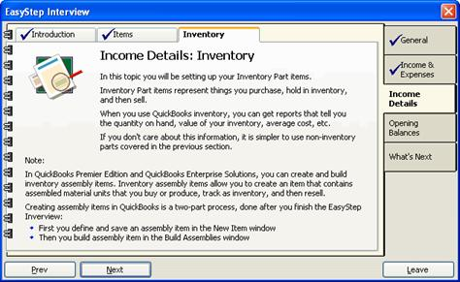
Tracking inventory in QuickBooks lets you produce reports showing quantity on hand, inventory value, cost and other information. However, many businesses choose to track inventory outside QuickBooks. If you indicated in the General section of the interview that you did not need to track inventory, you will be given an opportunity to either skip this section or to set up inventory items anyway.
To set up inventory items:
- Click Next.
- Select I want to set up inventory items:
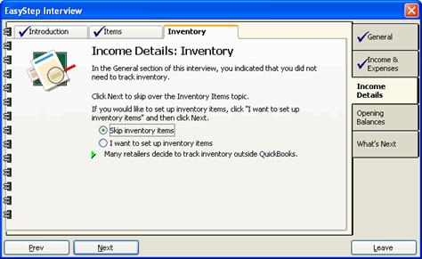
Alternatively, you can select Skip inventory items to proceed to the Opening Balances section.
- Click Next.
- If you opted to add an inventory item, the following screen appears:
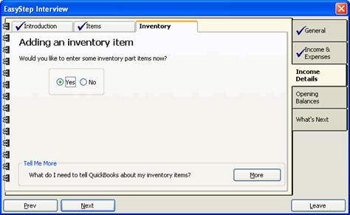
- Select Yes and click Next.
- Enter an item name, sales description and unit price:
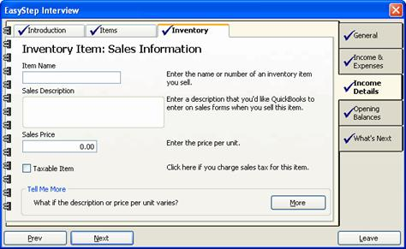
- If you charge sales tax for the item, check the Taxable Item box.
- Click Next.
- From the drop-down menu, select the income account to associate with the item:
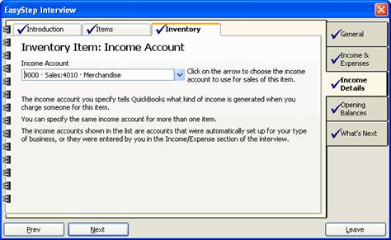
- Click Next.
- Enter a purchase description and the unit cost you pay for the item:
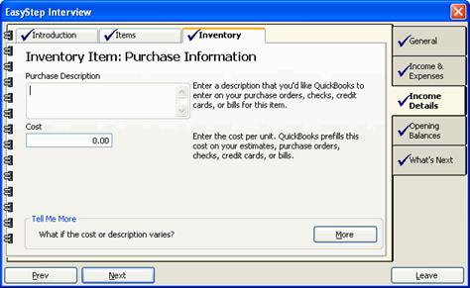
- Click Next.
- Enter a reorder point for the item:
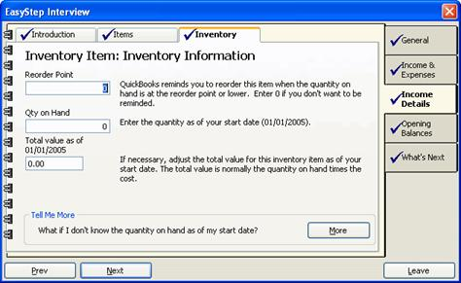
The reorder point is the number of units you want to have remaining in your inventory when QuickBooks reminds you to reorder.
- Enter the number of items in inventory as of your start date.
- Enter the total value of the inventory as of your start date. It's important to enter an accurate value here; however, if you're unsure of the value, you can make an inventory adjustment later.
- Click Next.
- To set up another inventory item, select Yes and click Next. Repeat the above steps until you've finished setting up your inventory items.
- To complete the Inventory screens, select No and click Next:
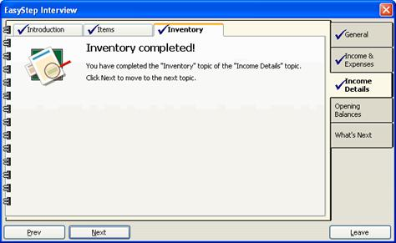
This completes the Income Details section of the interview. Click Next to proceed to Opening Balances.
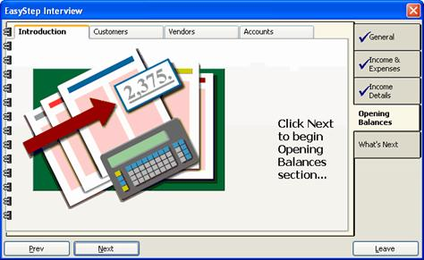
The Opening Balances section of the interview prompts you for information on the balances of your accounts as of your start date, as well as the customers who owed you money and the vendors to whom you owed money at that time.
These balances should reflect your start date, rather than the current date, since you'll be entering historical transactions. If you use the current date, your balances may not be accurate.
Before completing this section, you should have on hand the following information:
- Bank statements for the periods representing your start date.
- The values of assets and liabilities as of your start date.
- Customer names and the amounts they owed as of your start date.
- Vendor names and the amounts you owed them as of your start date.
To proceed:
- Continue to click Next until you reach the Enter customers screen:
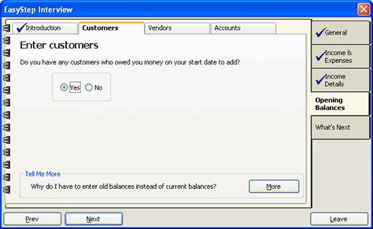
- If any customers owed you money as of your start date, select Yes; otherwise, select No to proceed to Vendors (Step 11, below).
- Click Next.
- If you selected Yes, select whether or not you want to track jobs (individual projects) for customers:
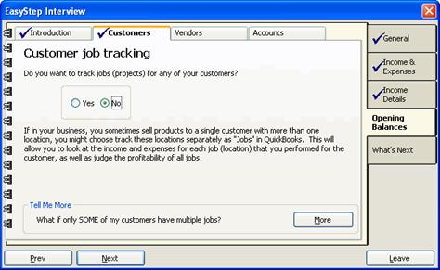
- Click Next.
- Enter the customer's name and the balance owed to you on the start date:
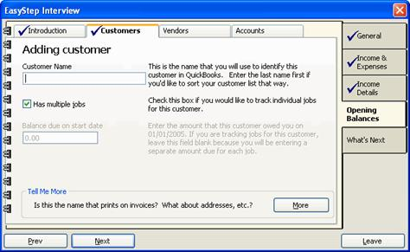
- If you opted to track customer jobs, a Has multiple jobs checkbox is available. Check this box if you're tracking more than one job for this customer.
- Click Next.
The customer's name appears in the Customer list.
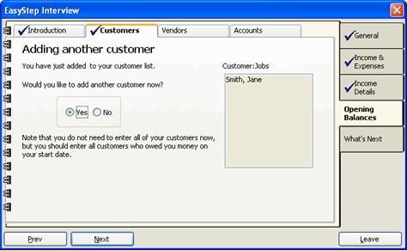
- To add another customer, select Yes and click Next. Repeat the above steps until you've finished adding customers with outstanding balances.
After you've completed the interview, you'll be able to add additional details for these customers, as well as those customers who didn't have balances at your start date.
- To complete the Customers screens, select No and click Next:
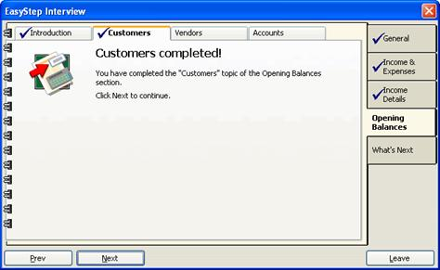
- Click Next to proceed to the Vendors screens.
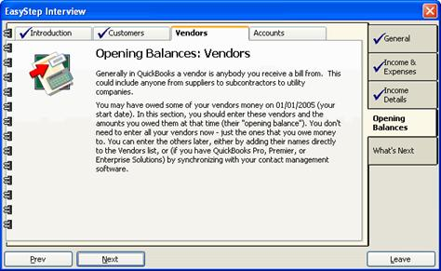
- If you owed money to any vendors as of your start date, select Yes; otherwise, select No to proceed to Vendors (Step 18, below).
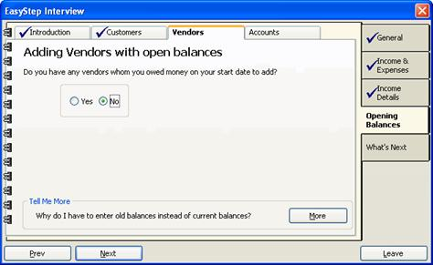
- Click Next.
- If you selected Yes, enter a name for the vendor and the balance you owed as of your start date:
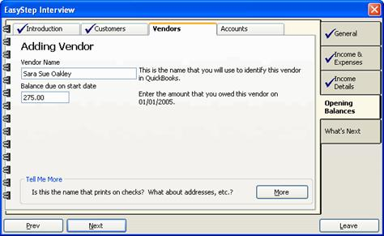
- Click Next.
- To add another vendor, select Yes and click Next. Repeat the above steps until you've finished adding the vendors to whom you owed money.
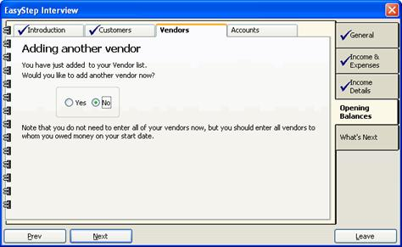
After you've completed the interview, you'll be able to add additional details for these vendors, as well as new vendors as necessary.
- To complete the Vendors screens, select No and click Next:
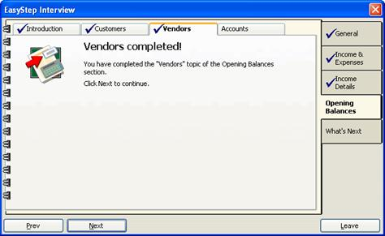
- Click Next to proceed to the Accounts screens.
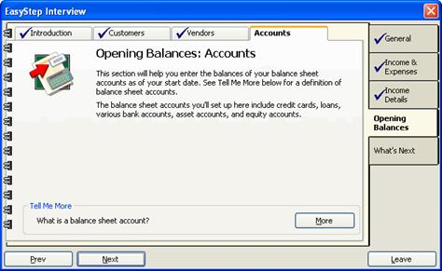
You use the Accounts screens to set up your balance sheet accounts. Balance sheet accounts are those showing your company's assets and liabilities. They include bank accounts, property, credit cards, loans and equity accounts.
- Click Next to set up your credit card accounts.
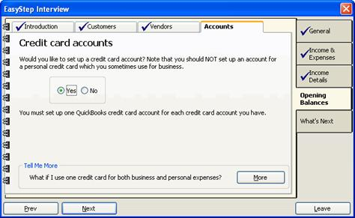
- If your company has a credit card account, select Yes; otherwise, select No to proceed to lines of credit (Step 28, below).
- Click Next.
- If you selected Yes, enter a name for the credit card:
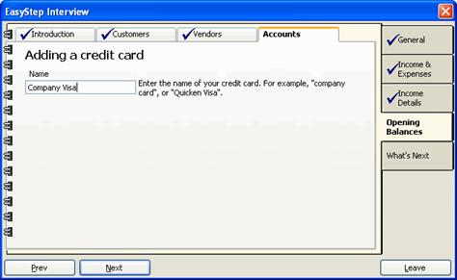
- Click Next.
- Enter the date of the statement closest to your start date:
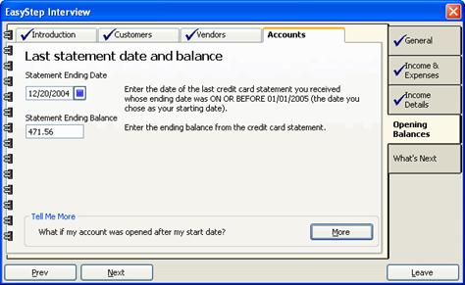
- Enter the ending balance shown on that statement.
- Click Next.
- To add another credit card account, select Yes and click Next. Repeat the above steps until you've finished adding your company's credit cards.
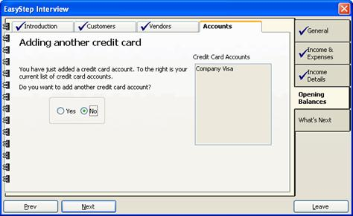
- To proceed to lines of credit, select No and click Next:
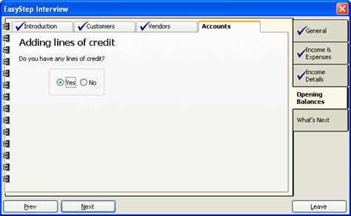
- If your company has a line of credit, select Yes; otherwise, select No to proceed to loans and notes payable (Step 37, below).
- Click Next.
- If you selected Yes, enter a name for the credit line:
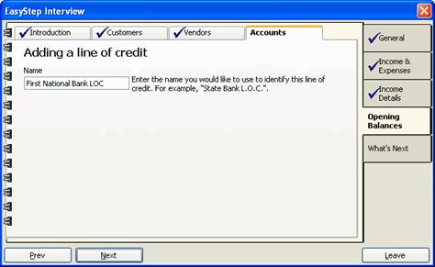
- Click Next.
- Enter the date of the statement closest to your start date:
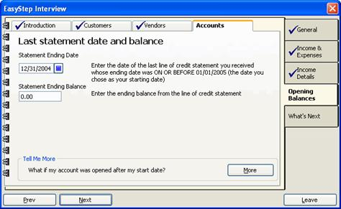
- Enter the ending balance shown on that statement.
- Click Next.
- To add another credit line, select Yes and click Next. Repeat the above steps until you've finished adding your company's credit lines.
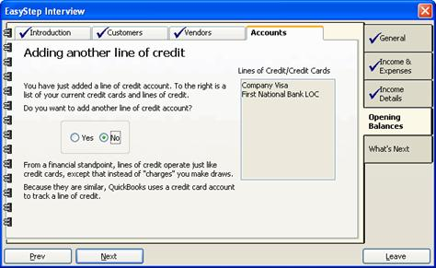

- To proceed to loans and notes payable, select No and click Next:
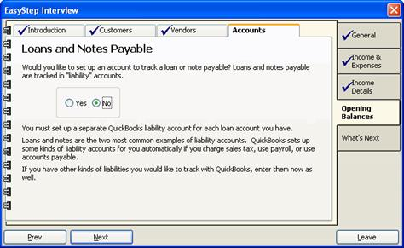
- If your company has taken out any loans, select Yes; otherwise, select No to proceed to bank accounts (Step 44, below).
- Click Next.
- If you selected Yes, enter a name for the loan and the outstanding balance as of your start date:
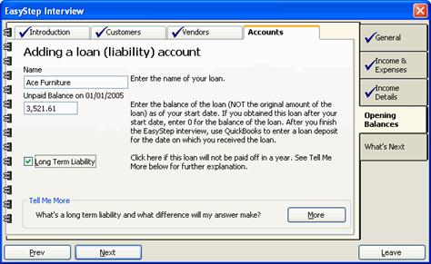
- If the loan will not be paid off within a year, check the box indicating that it's a long-term liability.
- Click Next.
- To add another loan, select Yes and click Next. Repeat the above steps until you've finished adding your company's loans.
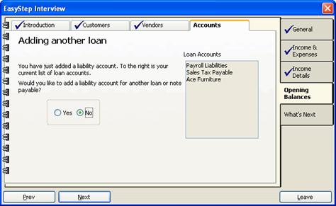
- To set up your bank accounts, select No and click Next:
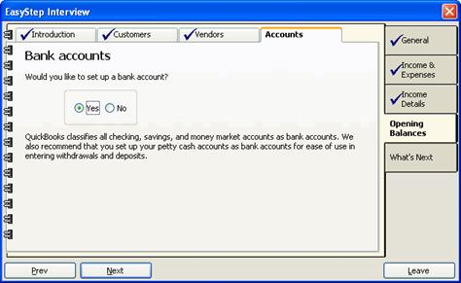
- Select Yes to add a bank account and click Next.
- Enter a name for the account:
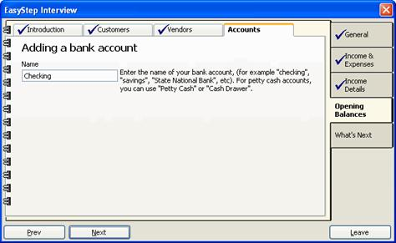
- Click Next.
- Enter the date of the statement closest to your start date:
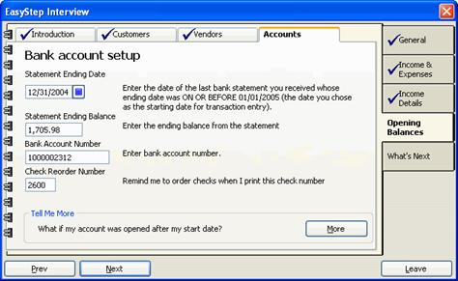
- Enter the ending balance shown on that statement.
If you opened the account after your start date, enter 0 for the account balance.

- Enter the account number and a check reorder number.
- Click Next.
- To add another account, select Yes and click Next. Repeat the above steps until you've finished adding your company's bank accounts.
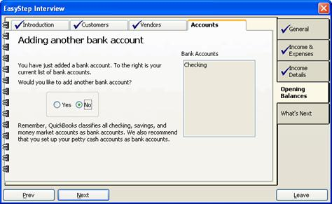
- When you've finished adding your accounts, select No and click Next to proceed.
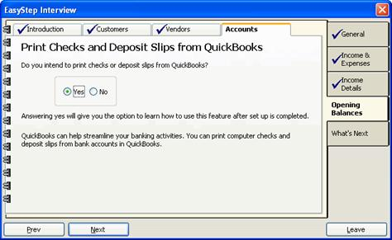
- If you want to use QuickBooks to print checks and deposit slips for your accounts, select Yes; otherwise select No.
- Click Next.
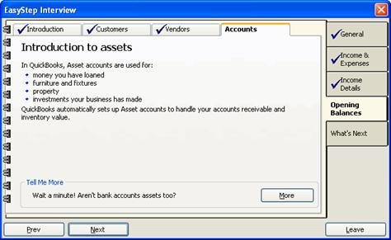
- Click Next to begin entering your company's assets.

In QuickBooks, “assets” refers to property, investments and money you've loaned. While bank and inventory accounts are also considered assets, these are tracked separately.
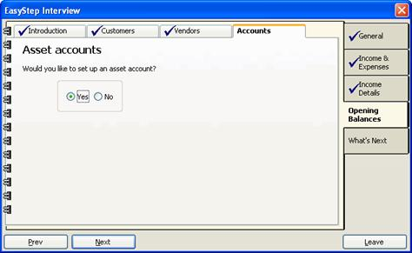
- To add an asset, select Yes; otherwise, select No to proceed to equity accounts (Step 68, below).
- Click Next.
- Enter a name for the asset:
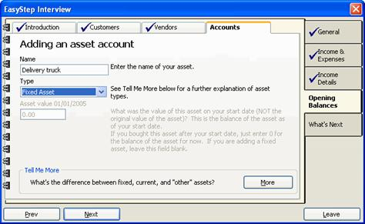
- From the drop-down menu, select the type of asset you're adding:
  - Fixed assets are those you own for a year or more, such as buildings, vehicles or office equipment. Selecting Fixed Asset lets you track depreciation of these items.
  - Select Other Current Asset if the asset is easily converted to cash, such as stock or a certificate of deposit.
  - Select Other Asset for everything else. This includes loans you've made.
- If you selected Other Current Asset or Other Asset, enter the value of the asset as of your start date.
If you selected Fixed Asset, the next two screens will prompt you for additional information.
- Click Next.
- If you selected Fixed Asset, the following screen asks you whether or not you want to track depreciation:
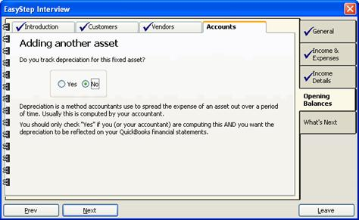
Select Yes if you want depreciation to be reflected in your financial statements.
- Click Next.
- If the item is a fixed asset, enter its value as of the start date:
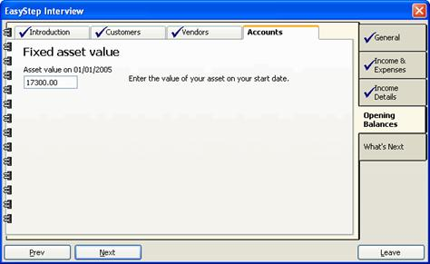
- Click Next.
- To add another asset, select Yes and click Next. Repeat the above steps until you've finished adding your company's assets.
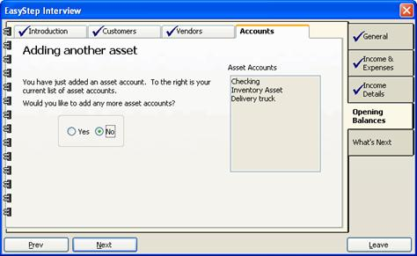
- To proceed to equity accounts, select No and click Next.
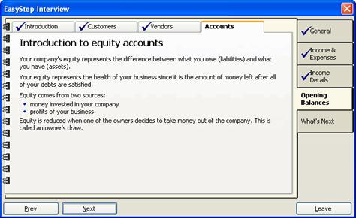
QuickBooks automatically sets up equity accounts to track the net worth of your business. Equity results from profits and from money invested in the company, and is calculated by subtracting your company's total liabilities from its total assets.
- Click Next to view the equity accounts QuickBooks has established.
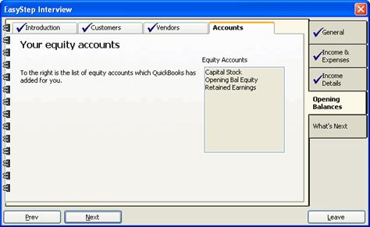
- Click Next again to complete the Accounts screens. This also completes the Opening Balances section of the interview.
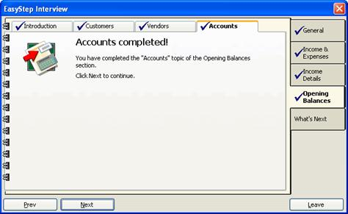
Continue to click Next to proceed through the informational topics contained in the What's Next section of the EasyStep interview. When you've finished, click Leave to exit the interview and begin using QuickBooks.
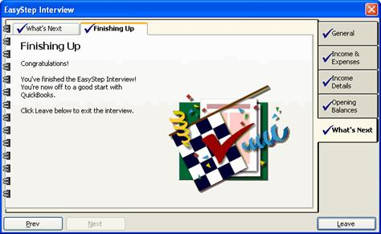
The next section of this tutorial describes how to use the QuickBooks interface. The following section will guide you through the remainder of the tasks you'll need to complete to finish setting up your business.
In this section, you learned how to:
- Setup Quickbooks for your company
- Convert data from Quicken
- Create a new company file
Navigating in Quickbooks
In this section, you will learn how to:
- Use the Quickbooks interface
- Use the toolbars and shortcuts
Navigating in QuickBooks
The QuickBooks interface uses “navigators” to group related tasks and information, such as company information, customer information and vendor information. The navigators are listed on the left-hand side of the QuickBooks window:
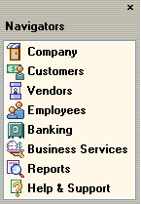
When you click on a navigator in the list, the main window for that navigator opens:
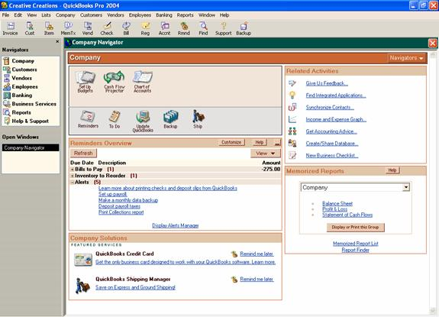
The Company Navigator, shown above, displays icons you can select for accomplishing particular company-related tasks, such as setting up budgets or opening the Chart of Accounts.
Each navigator is divided into panels that group related tasks or information. The primary navigators—Company, Customer, Vendor, Employee and Banking—each have panels for tasks (containing icons), related activities, memorized reports and solutions (a kind of QuickBooks marketplace). You can click on an icon or a hyperlink in any of these panels to open the linked window.

Each time you open a new window, QuickBooks displays it in the Open Windows list on the left-hand side of the QuickBooks window:
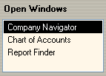
To move between open windows, simply click on a window in the list.
To close an open window, click the close button in the upper right-hand corner of the window. Make sure you aren't clicking the close button in the upper-right corner of the QuickBooks window; this will close QuickBooks entirely.
All of the options available in the navigators can be accessed from the QuickBooks menu bar, which also groups related tasks, such as company tasks, customer tasks and vendor tasks.
In addition, QuickBooks includes a toolbar that provides quick access to the commands you'll use most frequently:
- Click Invoice to create invoices for customers.
- Click Cust to open your customer list, where you can add, edit and delete customer information.
- Click Item to open your item list, where you can add, edit and delete item information.
- Click MemTx to open your memorized transaction list, where you can add, edit and delete memorized transactions.
- Click Vend to open your vendor list, where you can add, edit and delete vendor information.
- Click Check to write checks.
- Click Bill to pay bills.
- Click Reg to view and work with your account registers.
- Click Accnt to open your chart of accounts, where you can add, edit and delete account information, and enter transactions for accounts.
- Click Rmnd to view your reminders list.
- Click Find to search for transactions.
- Click Support to open the Help & Support window.
- Click Backup to back up your company file.
In this section, you learned how to:
- Use the Quickbooks interface
- Use the toolbars and shortcuts
In this section, you will learn how to:
- Backup your Quickbooks data
- Set up users and passwords
- Manage your accounts
- Set up classes
- Manage your customer information
- Manage your vendor information
- Manage your items
- Enter historical transactions

Completing Your Business Setup
Backing Up Your Data
Once you've completed the business setup process, you should back up your QuickBooks file:
- Click the Backup button 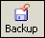 on the QuickBooks toolbar. You can also click the Backup icon in the Company Navigator or select Back Up from the QuickBooks File menu.
The QuickBooks Backup dialog box opens.
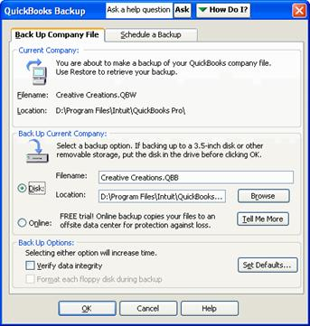
- Under Back Up Current Company, make sure Disk is selected. Then click the Browse button to browse to the location where you want to save the backup file.
- Click OK.
It's a good idea to schedule automatic backups, so the data in the backup file is kept up to date. You can have QuickBooks automatically back up your file when you exit the program:
- In the QuickBooks Backup dialog, select the Schedule a Backup tab.
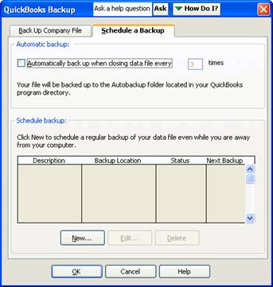
- Select the checkbox under Automatic backup (Automatically back up when closing data file every); then enter the frequency with which you want to back up the data. For example, enter 3 to have QuickBooks back up the data every 3 times you exit the program.
- Click OK.
Creating an Automatic Backup in Quickbooks
You can also schedule QuickBooks to create a new backup file at the days and times you specify; in this case, QuickBooks will save a specified number of backup files:
- In the QuickBooks Backup dialog, select the Schedule a Backup tab.
- Click the New button.
- In the Schedule a Backup dialog, enter a description for the backup. This will appear in the list of scheduled backups in the QuickBooks Backup dialog.
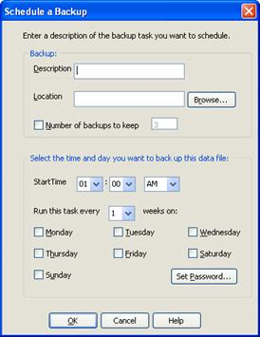
- Click the Browse button to browse to a folder where you want to keep the backup files.
- If you want to limit the number of backup files to keep, select the Number of backups to keep checkbox and enter the number of files you want to save. Otherwise, QuickBooks will save all the backup files.
- Select the start time and frequency for creating the backups.
Note: When QuickBooks backs up the data, your computer must be running and you cannot be using the company file that's being backed up.
- Some platforms require a password for the Windows user logged in while the backup is being performed. To enter your Windows login password, click the Set Password button. Confirm that the correct Windows user name is entered and enter your password; then click OK.
- Click OK to save the new backup schedule.
- Click OK to close the QuickBooks Backup dialog.

Setting Up Users and Passwords
Only the QuickBooks administrator can set up new users.
- From the Company menu, select Set Up Users.
The User List window opens.
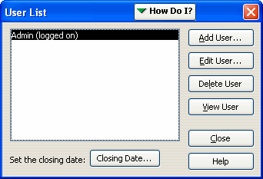
- Click the Add User button.
The Set up user password and access window opens.
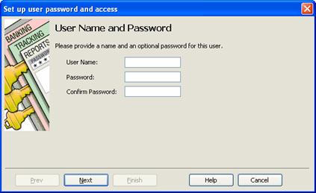
- Enter a user name and password for the new user.
- Click Next.
- Select whether or not you want to limit the user's access to selected areas:
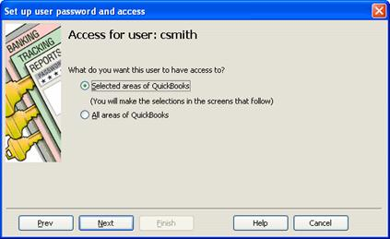
- Click Next.
- If you granted the user access to all areas of QuickBooks, confirm the selections and click Finish; otherwise, for each screen, select the level of access the user should have and click Next:
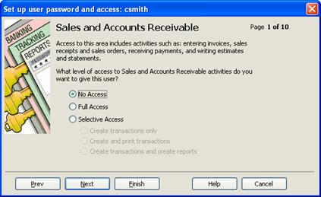
- When you've completed all the screens, review the access rights you granted:
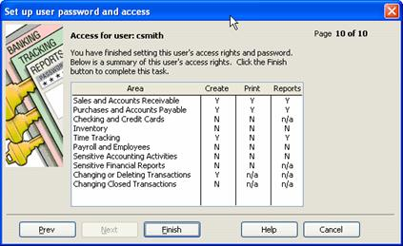
To make a change, click Prev to backtrack through the screens.
- Click Finish.
- Click Close to close the User List window.

Managing Your Accounts
The Chart of Accounts lists all the accounts you've created for your company. From here, you can add, edit and delete accounts, open the register for a particular account and enter account transactions.
To open the Chart of Accounts, click the Accnt 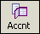 button on the QuickBooks toolbar, or select Chart of Accounts from the Lists menu. You can also access the Chart of Accounts by clicking the Chart of Accounts icon in the Company Navigator.
The Chart of Accounts opens in a new window:
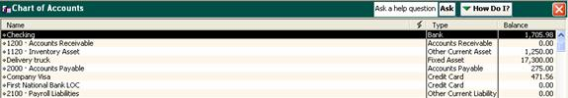
Double-clicking any account in the list opens the account register, where you can view and enter account transactions.
The buttons at the bottom of the window contain commands for accomplishing account-level tasks, such as creating and editing accounts, writing checks and running reports.
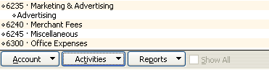
Setting up New Accounts
You can add a new account at any time after you've completed the business setup process:
- On the QuickBooks toolbar, click the Accnt button, or select Chart of Accounts from the Lists menu.
- At the bottom of the Chart of Accounts, click the Account button and select New from the menu that appears:
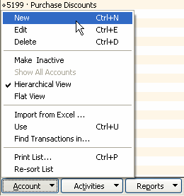
The New Account window opens.
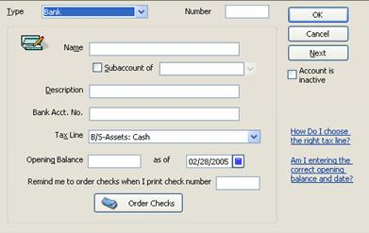
- From the Type drop-down menu, select the account type.
- In the Name field, enter a name for the account.
- If the account numbering option is turned on, enter a number for the account into the Number field.
The account numbering option lets you select accounts by the numbers you've given them. Developing and using a numbering scheme can help you select accounts quickly when completing forms. To turn on the option, select Preferences from the Edit menu. In the Preferences window, select the Accounting icon from the list on the left, and then select the Company Preferences tab. Finally, check the Use account numbers box and click OK.
- You can make the account a subaccount by checking the Subaccount of box. Select the parent account from the drop-down menu.
- If you like, enter a description for the account into the Description field.
- Enter the account number into the Bank Acct. No. field.
- If the account is an income or expense account, select a tax line from the Tax Line drop-down menu; otherwise, select <Not tax-related>.
- Enter the opening balance and your business start date. If the account is new, use the date the account was opened.
- Click OK to add the account and close the window. Or, to add another account, click Next.

Deleting Accounts
You can delete an account as long as it has no balance and is not used in payroll. To delete an account:
- In the Chart of Accounts, highlight the account you want to delete.
- Click the Account button and select Delete from the menu.
- When prompted, click OK to confirm that you want to delete the account.
Generally, unless the account was created in error, it's better to maintain records for it. You can do this while hiding the account from daily operations by inactivating it.

Inactivating and Reactivating Accounts
When an account is inactive, it does not appear in drop-down menus or in the Chart of Accounts unless you select the Show All Accounts option. You might make an account inactive, for example, when the account is closed but you want to maintain a record of it.
To inactivate an account:
- In the Chart of Accounts, highlight the account you want to inactivate.
- Click the Account button and select Make Inactive from the menu.
The account disappears from the Chart of Accounts. To view it in the list, click the Account button and select Show All Accounts. Inactive accounts appear with an X next to them.
To reactivate an inactive account:
- In the Chart of Accounts, make sure the Show All Accounts option is turned on.
- Highlight the account you want to reactivate.
- Click the Account button and select Make Active from the menu.

Editing Account Information
To edit account information:
- In the Chart of Accounts, highlight the account you want to edit.
- Click the Account button and select Edit from the menu.
- Make the necessary changes to the fields and click OK.

Changing the Opening Balance for an Account
If you need to adjust the opening balance you recorded for an account, you should open the account register and adjust the amount of the transaction:
- In the Chart of Accounts, double-click the account whose opening balance you need to change.
The account register opens.
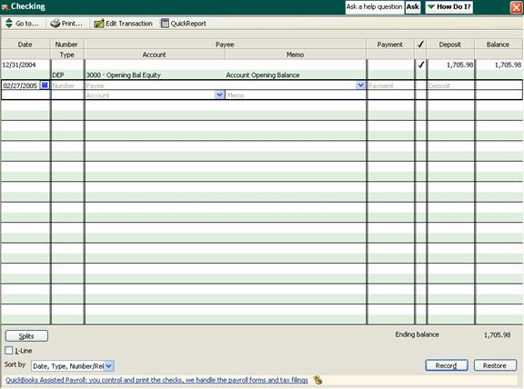
- Click inside the Deposit field for the opening balance transaction. This is usually the first transaction in the register and is labeled Opening Bal Equity in the Account column.
- Change the amount recorded.
- Click the Record button at the bottom of the window, or press Enter.
- When prompted, click Yes to confirm the change.
- To close the register, click the close button in the upper right-hand corner of the window.

Setting Up Classes
The Class List lists all the classes you've created for your account transactions. Classes let you break down your business by transactions, so that you can track income and expenses by the various segments of your business, such as a retail location, a department or a particular enterprise. When classes are enabled, a Class field appears in your various account registers, letting you select a class for the transactions you enter.
If you enabled the use of classes during the EasyStep Interview, you can set up your classes now. If you didn't enable classes and want to do so now, or you want to turn off classes:
- From the Edit menu, select Preferences.
- In the Preferences window, select the Accounting icon from the list on the left, and then select the Company Preferences tab.
- Check the Use class tracking box (or uncheck the box if you want to turn off the option).
- Click OK.
To open the Class List, select Class List from the Lists menu. From here, you can add, edit or delete a class using the Class button at the bottom of the window.
To add a new class:
- In the Class List, click the Class button and select New.
The New Class window opens.
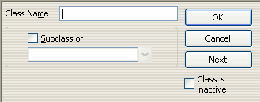
- Enter a name for the class.
- To make the class a subclass, select the Subclass of checkbox and then select the parent class from the drop-down menu. If necessary, select <Add New> and, in the window that opens, enter a name for the new parent class and click OK.
- Click OK to save the class, or Next to save the class and add a new one.

Managing Your Customer Information
The Customer List lists all the customers you've entered for your company. From here, you can add, edit and delete customer information, add jobs for a customer, create invoices, receive payments and run customer-related reports.
To open the Customer List, click the Cust 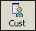 button on the QuickBooks toolbar, or select Customer:Job List from the Lists menu. You can also access the Customer List by clicking the Customers icon in the Customer Navigator.
The Customer List opens in a new window:
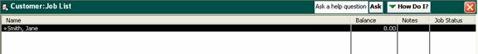
Double-clicking any customer name in the list opens the Customer window, where you can view and enter detailed information for that customer.
The buttons at the bottom of the window contain commands for accomplishing customer-level tasks, such as entering customer information, adding jobs, creating invoices and running customer reports.
Adding Customers
To add a new customer:
- On the QuickBooks toolbar, click the Cust button, or select Customer:Job List from the Lists menu.
- At the bottom of the Customer List, click the Customer:Job button and select New from the menu that appears:
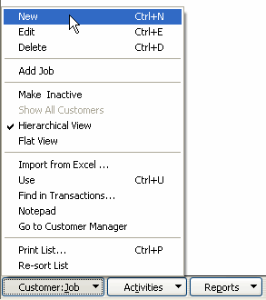
The New Customer window opens.
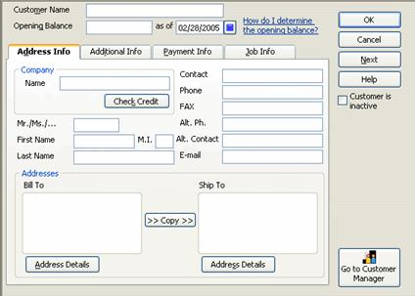
- Enter the name of the customer as you want it to appear in the Customer List (for example, Smith, Jane).
- If the customer has an outstanding balance, enter the balance and the date the balance reflects.
Note: If you are going to track jobs for the customer, don't enter an opening balance; QuickBooks will calculate this for you.
- The tabs on the window provide fields for entering detailed information for the customer, such as address information, payment terms, payment methods, and job information. Select each tab and complete the fields as appropriate. All this information is optional.
Note: To enter a billing address for the customer, click the Address Details button under the Bill To box. Complete the address fields in the window that opens and click OK. You can then click the >>Copy>> button to copy the address to the Ship To box, or you can click the Address Details button under the Ship To box to enter a different shipping address.
- Click OK to save the customer information, or Next to save the customer information and add a new customer.

Adding Jobs for a Customer
To add a job for an existing customer:
- In the Customer List, highlight the customer.
- Click the Customer:Job button and select Add Job from the menu.
The New Job window opens.
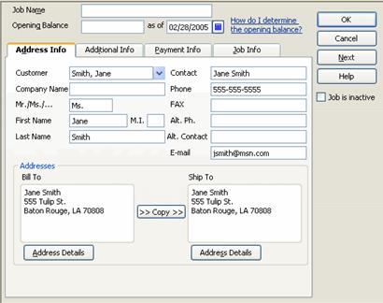
- Enter a name for the job.
- If necessary, make changes to the customer address and payment information.
- Select the Job Info tab.
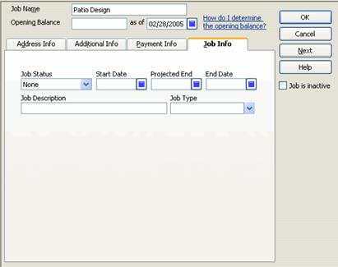
- Select the job status and enter a start date and projected end date for the job. Leave the end date blank until you've finished the job.
- Enter a job description.
- Select a job type from the drop-down menu, or select <Add New> to define a new job type.
If you selected a new job type, complete the job type fields in the window that appears and click OK.
- Click OK to save the job, or Next to save the job and add a new one.

Editing Customer Information
To edit customer information:
- In the Customer List, double-click the customer's name.
- In the Edit Customer window, make your changes as necessary and click OK.
To adjust a customer's opening balance:
- In the Customer List, click the Activities button and select Use Register.
- Select the customer's opening balance transaction, if you entered one. Otherwise, select the first of any individual transactions you need to adjust.
- Click inside the Amt Chrg column for the transaction and change the amount. Do the same for any additional transactions you need to change.
- Click the Record button, or press Enter.
- To close the register, click the close button in the upper right-hand corner of the window.

Updating Customer Jobs
QuickBooks does not automatically update job status or completion dates. To change the status of a job, or to enter an end date:
- In the Customer List, double-click the job under the customer's name, or double-click the customer's name and, in the Edit Customer window, select the Job Info tab.
- Make your changes as necessary and click OK.

Managing Your Vendor Information
Vendors include any businesses, tax agencies and individuals with whom you do business. The Vendor List lists all the vendors you've entered for your company. From here, you can add, edit and delete vendor information, create purchase orders, pay bills and run vendor-related reports.
To open the Vendor List, click the Vend 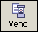 button on the QuickBooks toolbar, or select Vendor List from the Lists menu. You can also access the Vendor List by clicking the Vendors icon in the Vendors Navigator.
The Vendor List opens in a new window:
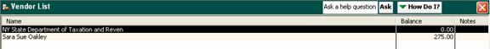
Double-clicking any vendor name in the list opens the Vendor window, where you can view and enter detailed information for that vendor.
The buttons at the bottom of the window contain commands for accomplishing vendor-level tasks, such as entering vendor information, creating purchase orders and running vendor reports.

Adding Vendors
To add a new vendor:
- On the QuickBooks toolbar, click the Vend button, or select Vendor List from the Lists menu.
- At the bottom of the Vendor List, click the Vendor button and select New from the menu that appears:
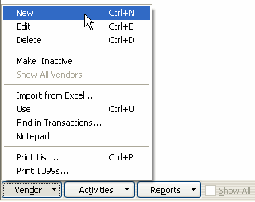
The New Vendor window opens.
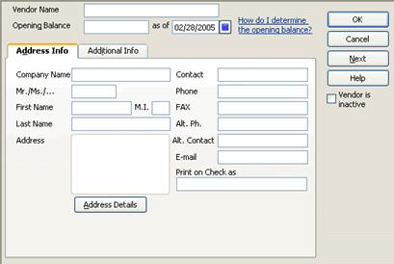
- Enter the name of the vendor as you want it to appear in the Vendor List (for example, Smith, Jane).
Note: The same name cannot appear in more than one QuickBooks list. If the vendor you're adding is also a customer, you'll have to vary the name slightly; for example, you can add the word vendor to the end of the name. In forms and on checks, QuickBooks will use the name you enter into the Print on Check as field.
- If you have an outstanding balance with this vendor, enter the balance and the date the balance reflects.
- The tabs on the window provide fields for entering detailed information, such as the vendor's contact information, your account number and your credit limit with the vendor. Select each tab and complete the fields as appropriate. All this information is optional.
To enter the vendor's address, click the Address Details button and complete the fields in the window that opens. Click OK to save the address and close the window.
- Click OK to save the information, or Next to save the information and add a new vendor.

Editing Vendor Information
To edit vendor information:
- In the Vendor List, double-click the vendor's name.
- In the Edit Vendor window, make your changes as necessary and click OK.
To adjust your opening balance with the vendor:
- Open the Chart of Accounts by clicking the Accnt button on the QuickBooks toolbar or selecting Chart of Accounts from the Lists menu.
- In the Chart of Accounts, highlight Accounts Payable.
- Click the Activities button and select Use Register.
- In the register, select the vendor's opening balance transaction and change the amount in the Billed column.
- Click the Record button, or press Enter.
- To close the register, click the close button in the upper right-hand corner of the window.

Managing Your Items
Items include all the goods and services you offer customers, as well as the taxes you charge and pay for them. The Item List lists all the items you've entered for your company. From here, you can add, edit and delete items, create invoices, receipts and purchase orders, change item prices and run item-related reports.
To open the Item List, click the Item 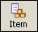 button on the QuickBooks toolbar, or select Item List from the Lists menu. You can also access the Item List by clicking the Items & Services icon in either the Customers or Vendors Navigator.
The Item List opens in a new window:
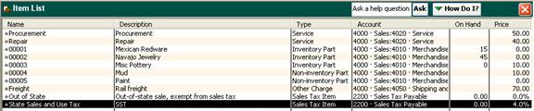
Double-clicking any item in the list opens the Item window, where you can view and enter detailed information for that item.
The buttons at the bottom of the window contain commands for accomplishing item-level tasks, such as entering item information, creating invoices and receipts and running item-related reports.

Adding Items
To create a new item:
- On the QuickBooks toolbar, click the Item button, or select Item List from the Lists menu.
- At the bottom of the Item List, click the Item button and select New from the menu that appears:
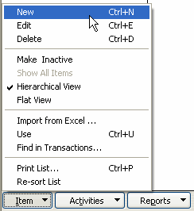
The New Item window opens.
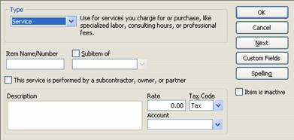
- Select the type of item you're adding from the drop-down menu.
Note: You cannot change a service item to another item type.
- The remainder of the fields on the window will vary depending on the type of item you select. For most, you should enter an item name or number; this will appear in item selection menus when you fill out forms.
- If appropriate, check the Subitem of box and select the parent item under which you want to this item to appear.
- Complete the remainder of the fields as appropriate.
- Click OK to save the item, or Next to save the item and add another one.

Editing Item Information
- In the Item List, double-click the item.
- Make the necessary changes and click OK.

Creating Sales Tax Items
If you selected multiple tax rates for your business during the EasyStep Interview, you can use the Item List now to set your sales tax items. Create an item for each sales tax rate, and for each sales tax agency:
- On the QuickBooks toolbar, click the Item button, or select Item List from the Lists menu.
- At the bottom of the Item List, click the Item button and select New from the menu that appears.
- In the New Item window, select Sales Tax Item from the Type drop-down menu.
- Enter a name for the sales tax.
- Enter a description for the sales tax; this description will appear on your sales forms.
- Enter the tax rate as a percentage (for example, 7.25%).
- Enter the tax agency.
- Click OK to save the tax item, or Next to save the item and add another one.

Setting Up Tax Groups
If you charge multiple taxes, consider setting up tax groups, which allow you to print sales tax as a single line item on an invoice:
- In the Item List, click the Item button and select New.
- From the Type drop-down menu, select Sales Tax Group.
- Enter a name for the group and description for the group. The description will appear on your forms.
- Click inside the Tax Item column of the list box. Click the down arrow button to select a tax item to include in the group.
QuickBooks automatically populates the rest of the columns for that item.
- Click inside the Tax Item column for the next row and select another tax item. Continue to select tax items until you've added all the necessary taxes to the group.
- Click OK to save the tax group, or Next to save the group and add another one.

Entering Historical Transactions
Once you've added all your accounts, vendors, customers and items, you should enter all your historical transactions. These are transactions that occurred between the start of your fiscal year and your QuickBooks start date. Include both cleared and uncleared transactions during that time.
It's extremely important to enter accurate and complete historical data, since QuickBooks uses this information in the reconciliation process.
You should enter historical transactions in the order in which they occurred, beginning with accounts payable transactions and ending with bank transactions. For each transaction, you'll need to complete the workflow process; for example, for a customer payment, you should create an invoice (or a sales receipt), receive the payment and then make the deposit. Finally, you should reconcile your bank account.

Day-to-Day Business Operations

Opening Your Company File
When you first open QuickBooks, you're prompted to log in to your default company file:
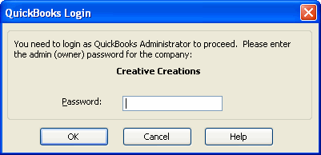
Enter your password and click OK.
To open another company file while using QuickBooks:
- From the File menu, select Open Company/Login.
- In the Open a Company dialog, browse to the location of the company file. Highlight the file and click Open.
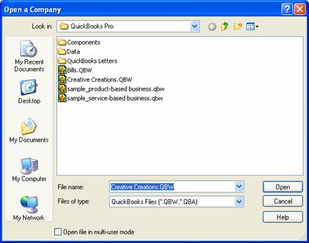
The QuickBooks Login dialog opens.
- Enter your password and click OK.

Ordering and Receiving Items
Use purchase orders to order goods or services from vendors. Purchase orders help you track what you order, what you receive and what you need to pay vendors. When you enter a bill for a vendor, QuickBooks lets you check the items you've received against the open purchase orders for that vendor, and updates your inventory as appropriate.
For over-the-counter purchases—that is, purchases you pay for at the time you receive the items—you can bypass the purchase order and simply write a check or enter a different kind of transaction (for example, a credit card transaction).
The Vendor Navigator displays the workflow for ordering and receiving items and paying bills, with shortcuts for creating purchase orders, receiving items, paying bills and paying sales tax:
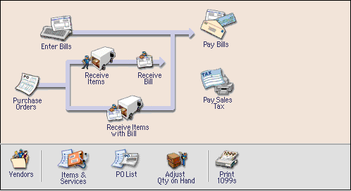
You can click any of these icons to accomplish the related task.
Viewing Your Purchase Orders
All the purchase orders you've created appear in the Purchase Orders List, which you can view by clicking the PO List icon in the Vendor Navigator, or by selecting Purchase Orders List from the Vendors menu.
From here, you can use the buttons at the bottom of the window to create, edit and delete purchase orders, receive items against a specific purchase order, enter bills and run purchase and inventory reports. Generally, however, it isn't necessary to go to the Purchase Order List to accomplish these tasks.
Note: You'll be unable to open the Purchase Orders List until you've created at least one purchase order.

Creating a Purchase Order
To create a purchase order:
- Click the Purchase Orders icon in the Vendor Navigator, or select Create Purchase Orders from the Vendors menu.
The Create Purchase Orders window opens.
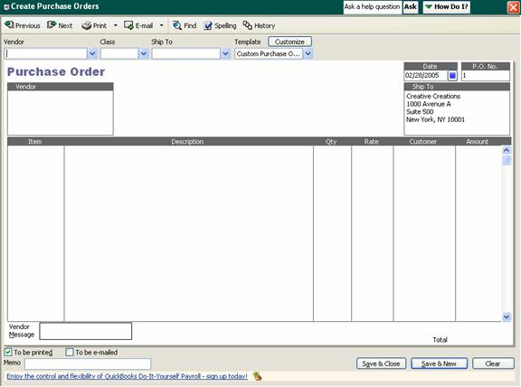
- Select a vendor from the drop-down menu.
- If appropriate, select a class to assign to the purchase order.
- If the order should be shipped to a customer or vendor instead of to you, select the name from the Ship To drop-down menu.
- Confirm the entries in the remainder of the fields, making changes or entering information as necessary. At the bottom of the window, you can enter a message for the vendor in the Vendor Message field and information for yourself in the Memo field.
- To enter an item, click inside the Item column and select the item from the drop-down menu.
- For each item you select, enter a description, quantity and rate, if the default rate you defined for the item is variable.
- If the item is for a specific customer or job, select the customer and/or job from the drop-down menu in the Customer column.
- When you've finished entering items, click the Save & Close button to save the purchase order, or the Save & New button to save the purchase order and create another one.
To print the purchase order, click the Print button at the top of the window. In the Print dialog, verify the printer settings and then click Print.
To print multiple purchase orders, click the down arrow on the Print button and select Print Batch. In the window that opens, select the purchase orders you want to print and click OK.

Receiving Items from Vendors
Once you receive items you've ordered using a purchase order, you should create an item receipt.
Note: If you received a bill with the items, enter a bill instead of an item receipt.
To create an item receipt:
- Click the Receive Items icon in the Vendor Navigator, or select Receive Items from the Vendors menu.
The Create Item Receipts window opens.
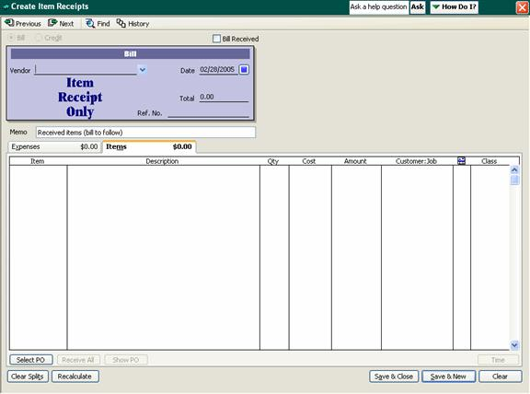
- Select the vendor from the drop-down menu. If open purchase orders exist for this vendor, QuickBooks prompts you to receive against them:
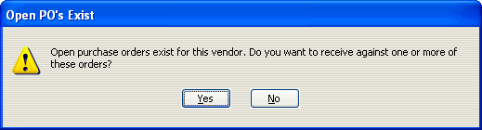
- Click Yes.
The Open Purchase Orders window opens.
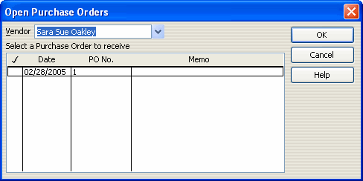
- Select the purchase order containing the items you're receiving and click OK. You can select more than one purchase order.
- QuickBooks completes the item receipt for you. If you need, you can make changes to any of the line items.
- Enter any expenses, such as shipping or taxes, on the Expenses tab, making sure to associate each with the appropriate expense account.
- Click Save & Close to save the item receipt, or Save & New to save the receipt and add another receipt.
You should create an item receipt even if you didn't create a purchase order, as long as the bill will arrive later; the only difference in the process is that you won't be prompted to receive the items against a purchase order. When you complete an item receipt, QuickBooks updates your inventory accordingly.
If you receive a bill with items, you should enter a bill instead of an item receipt.
For over-the-counter purchases (in which you receive and pay for items at the same time), write a check or enter a transaction for the account from which you're paying for the items.

Entering and Paying Bills

Entering Bills
You should enter bills for all expenses you don't pay immediately, including items you receive against a purchase order or for which you've created an item receipt. Bills for expenses are tracked using expense accounts, while bills for items are tracked using the Item or Fixed Asset Item List.
To enter a bill for items you've already received, and for which you've created an item receipt:
- In the Vendor Navigator, click the Receive Bill icon.
The Select Item Receipt window opens.
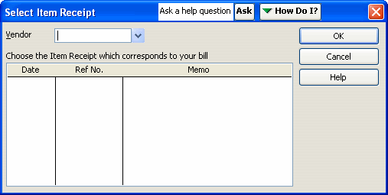
- Select the vendor from the drop-down menu.
- Select the item receipt that corresponds to the bill you received and click OK.
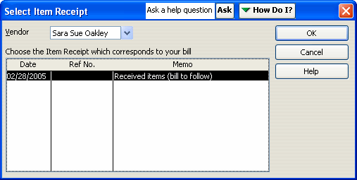
The Enter Bills window opens with the information contained in the item receipt.
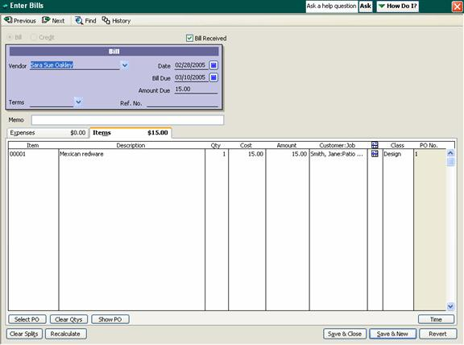
- Make changes to the information as necessary and click Save & Close.

To enter a bill for all other expenses, including items you've received for which you haven't created an item receipt:
- Click the Bill 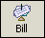 button on the QuickBooks toolbar, or select Enter Bills from the Vendors menu.
If you're receiving items from a vendor and the bill has been included with the items (that is, no item receipt exists), you can also click the Receive Items with Bill icon in the Vendor Navigator.
The Enter Bills window opens.
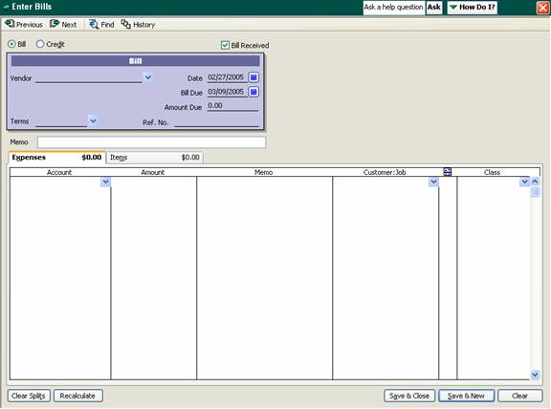
- If the bill is for an expense, select the Expenses tab. If the bill is for items you're purchasing, select the Items tab.
- At the top of the window, select the vendor from the drop-down menu, or enter a new one by typing directly into the field. If you entered a new vendor, you can click the Quick Add button when prompted and enter detailed information for the vendor later. (Alternatively, you can click the Set Up button when prompted to enter detailed vendor information now.)
- If a purchase order exists for this vendor, you're prompted to receive against it. Click Yes and, in the Open Purchase Orders window, select each purchase order containing the items reflected on the bill. Click OK.
- Change the date and due date of the bill as necessary.
- Enter the amount due and complete the Ref. No., Terms and Memo fields as necessary.
- If the bill is for an expense, select an expense account from the drop-down menu in the Account field. If the bill is for items, click inside the Item field and select the item from the drop-down menu. If you received the items against a purchase order, these items should already appear in the list; you can edit them as necessary.
Note: To enter charges not associated with a specific item, such as shipping or tax, select the Expenses tab and enter each charge, selecting the appropriate expense account.
- Click the Save & Close button to save the bill, or Save & New to save the bill and enter a new one.

Paying Bills
To pay a bill you've entered:
- Click the Pay Bills icon in the Vendor Navigator, or select Pay Bills from the Vendors menu.
- If necessary, select the accounts payable account to use.
The Pay Bills window opens.
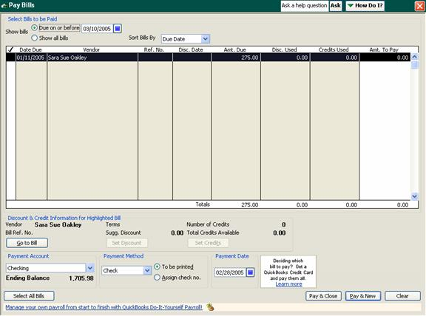
- You can filter the list of bills displayed in the window by selecting the Due on or before option and entering a date.
- To pay multiple bills, click inside the checkmark column for each bill. This places a checkmark next to each of the bills you select.
- If you have any discounts or credits, enter these into the Disc. Used and Credits Used fields.
- For each bill, enter the amount you're paying.
- Select a payment account and method from the drop-down menus at the bottom of the window and complete the remainder of the fields as appropriate.
- Click Pay & Close.

Writing Checks
To pay bills when you receive them, use the Write Checks window. Do not use this window to pay taxes or bills you've already entered.
To write a check:
- Click the Check 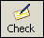 button on the QuickBooks toolbar, or select Write Checks from the Banking menu.
The Write Checks window opens.
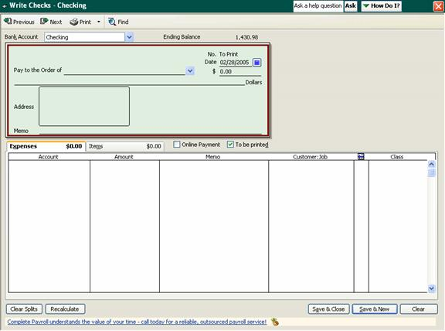
- Select the account you want to use from the Bank Account drop-down menu.
- Select a name from the Pay to the Order of drop-down menu.
- If an open purchase order exists for the payee, QuickBooks prompts you to receive items against it. Click Yes if you're paying for items you're receiving, or No if you're making an over-the-counter purchase.
If you're receiving items against a purchase order, select the purchase order in the window that opens and click OK. You can select multiple purchase orders if necessary.
- If you're receiving items against a purchase order, QuickBooks populates the remainder of the fields with the items contained in the purchase order and the total amount. You can edit this information as necessary. Otherwise, enter the amount you're paying into the $ field.
Note: You can leave the amount blank and have QuickBooks automatically complete it based on the total of the item amounts you enter.
- Add to or edit the Address and Memo fields as necessary.
- To enter an item, select it from the drop-down menu on the Items tab.
- For each item, enter the quantity and cost.
- If you're purchasing the item for a particular customer or job, select the customer and/or job from the Customer:Job drop-down menu.
- If appropriate, select the class in which the item belongs.
- Enter any expenses, such as shipping and taxes, using the Expenses tab. You should also use this tab if you're writing a check for an expense, such as a utility bill, rather than for items. Be sure to associate the expense with the appropriate expense account.
- If you'll be printing the check using your printer, make sure the To be printed box is checked; otherwise, uncheck this box and enter a check number.
- To print the check, click the Print button at the top of the window. In the dialog that opens, enter the printed check number and click OK. In the Print dialog, confirm the printer settings and click Print.
To print multiple checks, click the down arrow on the Print button and select Print Batch. In the window that opens, select the checks you want to print. Then enter the first check number and click OK.
- Click Save & Close to save the check, or Save & New to save the check and write a new one.

Paying Sales Tax
When the time comes to pay sales tax, you should use the Pay Sales Tax function, rather than Pay Bills or Write Checks:
- In the Vendor Navigator, click the Pay Sales Tax icon, or select Sales Tax, and then Pay Sales Tax, from the Vendors menu.
The Pay Sales Tax window opens.
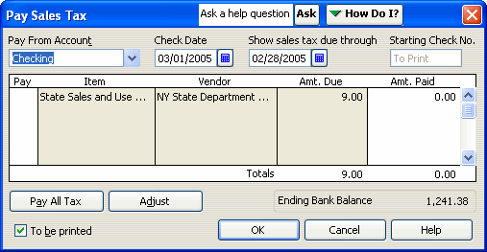
- Select the account to pay taxes from.
- Confirm the through date for the tax. If necessary, you can edit the date.
Note: To confirm or change the sales tax period set up for your company, select Preferences from the Edit menu. In the Preferences window, select the Sales Tax icon. Under Pay Sales Tax, select the appropriate tax period—monthly, quarterly or annually.
- Select the tax agencies you want to pay by clicking inside the Pay column. Alternatively, click Pay All Tax to pay all the taxes shown.
- To make a partial payment, change the amount in the Amt. Paid column.
- Click OK.

Memorizing Transactions
Memorizing a transaction saves its details so you can easily re-enter it on a regular basis; this is most useful for regular payments, such as utility bills. You can have QuickBooks remind you when the transaction needs to be entered, or automatically enter it for you.
To memorize a transaction:
- Enter the transaction (for example, a check or a bill) as you want it memorized.
Leave blank any fields you'll need to change, such as the Amount field, if the amount varies from transaction to transaction.
- From the Edit menu, select the appropriate Memorize command (such as Memorize Check or Memorize Bill).
The Memorize Transaction window opens.
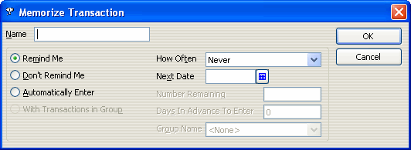
- Enter a name for the memorized transaction, such as Utility Bill.
- If you want QuickBooks to remind you to enter the transaction when it's due, select Remind Me; if you want QuickBooks to automatically enter the transaction for you, select Automatically Enter. Otherwise, select Don't Remind Me.
- If you opted to have QuickBooks remind you to enter the transaction, select how often you want to be reminded, and enter the date the reminders should begin.
- Click OK.
- If you created the transaction for the purpose of memorizing it, but don't want to enter the transaction now, click Clear and then close the window. Otherwise, save the transaction as usual.

Recording Sales
You can use two methods to track sales to customers, depending on when the customer pays you: invoices let you record sales when the customer isn't paying in full (or is paying in advance), while sales receipts record sales paid for in full at the time the goods or services were provided.
The Customer Navigator displays the workflow for recording sales, with shortcuts for creating invoices and sales receipts, receiving payments and making deposits:
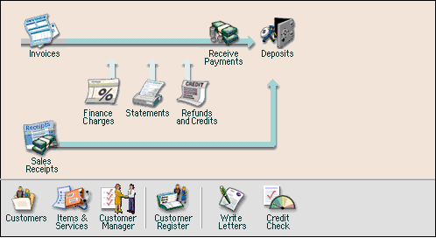
You can click any of these icons to accomplish the related task.

Creating an Invoice
Use invoices to track what customers owe you for goods and services, when they don't pay in full at the time of the sale, or when they pay in advance.
To create an invoice:
- Click the Invoice 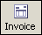 button on the QuickBooks toolbar, or select Create Invoices from the Customers menu.
- If QuickBooks asks if you want help selecting an invoice format, click No; this simply opens a checklist to help you determine whether to use invoices, sales receipts or statements.
The Create Invoices window opens.
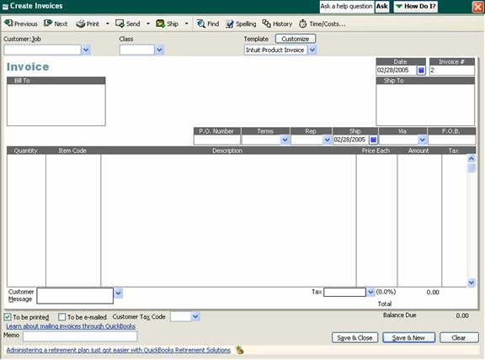
- Select the name of the customer and/or job from the drop-down menu.
- If the customer currently has outstanding billable costs, QuickBooks notifies you that this information is available:
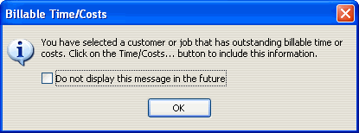
Click OK.
- If the customer has outstanding billable costs, click the Time/Costs button at the top of the invoice window to open the Choose Billable Time and Costs window:
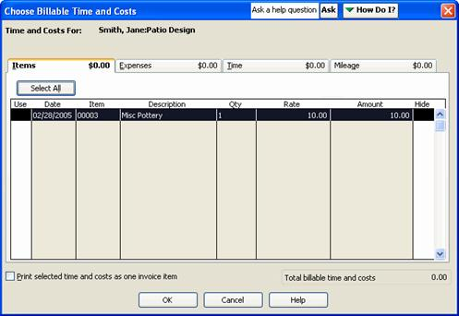
  - Review the items and expenses shown in the window by selecting the appropriate tabs.
  - Click inside the Use column for each item and expense to include in the invoice.
  - Click OK.
QuickBooks adds these items and expenses to the invoice. You can edit them as necessary.
- Select the class associated with the invoice, if applicable.
- Select an invoice template.
- For each item you need to add to the invoice, select the item from the drop-down menu in the Item Code column.
- Enter a quantity and adjust the price, if necessary.
- Confirm that the appropriate tax entry appears in the Tax column. If the item is non-taxable, select Non from the drop-down menu.
- Review the remainder of the fields, completing them as necessary. The Memo field is for your own use; any entry you make will not appear on the invoice you send to the customer, but it will appear in sales reports and on reminder statements.
- To print the invoice, click the Print button at the top of the window. Confirm the printer settings and click Print.
To print multiple invoices, click the down arrow on the Print button and select Print Batch. In the window that opens, select the invoices you want to print and click OK.
Alternatively, you can click the Send button to e-mail the invoice to the customer. In the window that opens, confirm the e-mail addresses being used and the body of the message, and then click Send Now (or Send Later, if you want to wait and e-mail several invoices at once). The invoice will be attached to the e-mail as a PDF file.
- Click the Save & Close button to save the invoice, or Save & New to save the invoice and add another one.

Receiving an Invoice Payment
Once you receive payment for an invoice, you need to apply the payment to the invoice:
- In the Customer Navigator, click the Receive Payments icon, or select Receive Payments from the Customers menu.
The Receive Payments window opens.
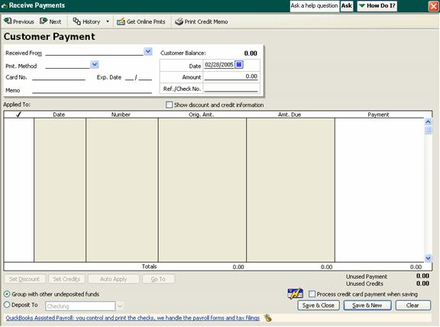
- Select the customer and/or job from the Received From drop-down menu.
QuickBooks automatically adds the outstanding charges from open invoices to the payment form.
- Enter the amount of the payment you received and complete the payment method fields.
- To apply the payment, click inside the first (checkmark) column for each of the line items to which you want to apply the payment. QuickBooks tracks the unused portion of the payment at the bottom right of the window.
To have QuickBooks automatically distribute the payment, click the Auto Apply button at the bottom of the window. QuickBooks automatically applies the payment to the oldest invoices first.
- If you want to wait to deposit the payment with other undeposited funds, select the Group with other undeposited funds option at the bottom of the window; otherwise, select the Deposit To option and the account that should receive the payment.
- Click Save & Close to save the payment, or Save & New to save the payment and add another one.
Creating a Sales Receipt
When you receive full payment from a customer at the time of sale, you should create a sales receipt instead of an invoice:
- In the Customer Navigator, click the Sales Receipts icon, or select Enter Sales Receipts from the Customers menu.
The Enter Sales Receipts window opens.
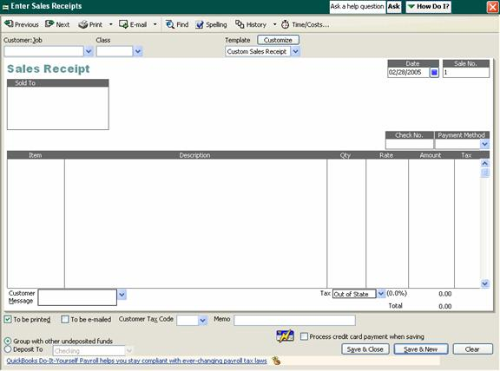
- Select the name of the customer and/or job from the drop-down menu.
- Select the class associated with the sale, if applicable.
- Select receipt template.
- Select the payment method from the drop-down menu.
- For each item you need to add to the receipt, select the item from the drop-down menu in the Item column.
- Enter a quantity and adjust the rate, if necessary.
- Confirm that the appropriate tax entry appears in the Tax column. If the item is non-taxable, select Non from the drop-down menu.
- Review the remainder of the fields, completing them as necessary. The Memo field is for your own use; any entry you make will not appear on the sales receipt.
- To print the receipt, click the Print button at the top of the window. Confirm the printer settings and click Print.
To print multiple receipts, click the down arrow on the Print button and select Print Batch. In the window that opens, select the receipts you want to print and click OK.
Alternatively, you can click the Send button to e-mail the receipt to the customer. In the window that opens, confirm the e-mail addresses being used and the body of the message, and then click Send Now (or Send Later, if you want to wait and e-mail several receipts at once). The receipt will be attached to the e-mail as a PDF file.
- If you want to wait to deposit the payment with other undeposited funds, select the Group with other undeposited funds option at the bottom of the window; otherwise, select the Deposit To option and the account that should receive the payment.
- Click the Save & Close button to save the receipt, or Save & New to save the receipt and add another one.

Creating Statements
You can create statements for customers showing outstanding balances and the length of time the balances have been outstanding:
- In the Customer Navigator, click the Statements icon, or select Create Statements from the Customers menu.
The Create Statements window opens.
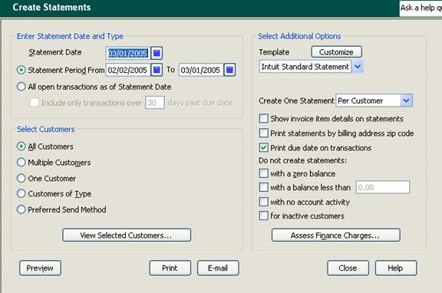
- If necessary, select the accounts receivable account from which to print statements.
- Confirm the statement date. This will appear at the top of the statements as the Billed Date, and affects the date due.
- Select whether to create statements for transactions within a particular date range or all open transactions.
- Select whether to print statements for all customers, multiple customers or one customer. Each of these options, with the exception of All Customers, provides a button or drop-down menu that lets you select the customers (or type of customers) to include. Make this selection as necessary.
- Select a template to use for the statements. You can customize the template as necessary by clicking the Customize button.
- To create a separate statement for each customer job, select Per Job from the Create One Statement drop-down menu; otherwise, select Per Customer.
- The remainder of the checkboxes let you select additional options. Check or clear these boxes as necessary.
- To add finance charges, click the Assess Finance Charges button.
  - If prompted, click Yes to set up finance charges.
  - In the Preferences window, select the options to use for assessing finance charges, including the annual interest rate and grace period, and then click OK.
  - In the Assess Finance Charges window, select the customers to whom the finance charges should be applied.
  - Click Assess Charges.
QuickBooks returns to the Create Statements window.
- Click Preview to preview the statements, and then click Print to print the statements, or E-mail to e-mail the statements to customers.

Depositing Payments
You can deposit individual payments at the time you enter an invoice payment or a sales receipt, or you can wait and deposit multiple payments at once. When you're ready to deposit a payment or payments:
- Click the Deposit icon in the Banking Navigator, or select Make Deposits from the Banking menu.
If there are currently undeposited funds from invoice payments or sales receipts, the Payments to Deposit window opens.
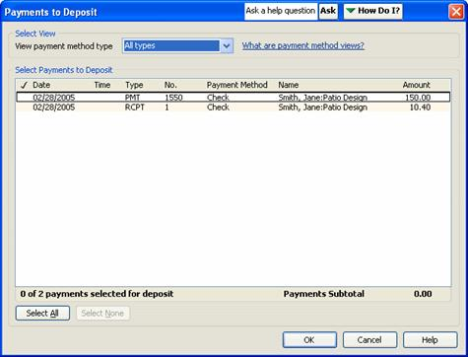
- Select the payments you want to deposit and click OK. If you don't want to deposit any of the payments, leave all the items unselected and click OK.
If you selected payments to deposit, the Make Deposits window opens.
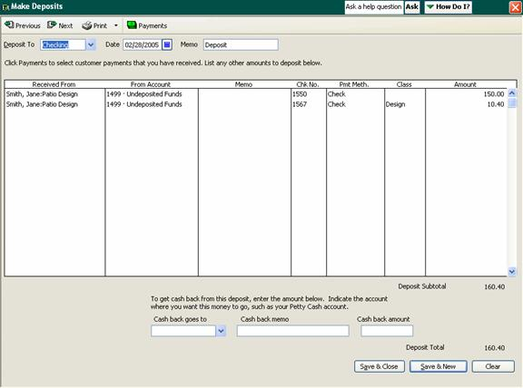
- Select the account the funds should be deposited into.
- Confirm the date and the entry in the Memo field, making changes as necessary.
- Enter any additional deposits as new line items. You can enter cash deposits separately for bookkeeping purposes; QuickBooks will total these and enter a single amount on the deposit slip.
Note: If you're entering a credit card payment, enter any fees you're charged as separate line items and associate them with an expense account. You cannot enter credit card payments on printable deposit slips.
- If you want to get cash back, select an account and enter the amount at the bottom of the window.
- To print the deposit slip or a deposit summary, click the Print button at the top of the window. Select whether to print the deposit slip and a summary or a deposit summary only. Then confirm the printer settings and click Print.
- Click Save & Close to save the deposit or Save & New to save the deposit and add another one.

Reconciling Your Bank Account
You should reconcile your bank account as soon as you've finished the business setup process and have entered all your historical transactions. You should then reconcile the register each time you receive a bank statement.
To reconcile your account:
- In the Banking Navigator, click the Reconcile icon, or select Reconcile from the Banking menu.
The Begin Reconciliation window opens.
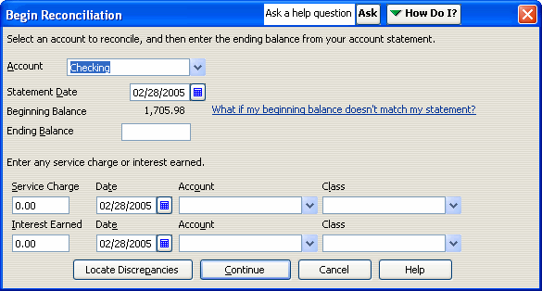
- Select the account you're reconciling from the drop-down menu.
- Enter the date of the bank statement you're using for reconciliation. If you're reconciling after entering historical transactions, you should use the bank statement that covers the start of your fiscal year.
- Compare the beginning balance QuickBooks has displayed with the beginning balance shown on your statement. If the balances are the same, continue with the next step. If the balances are different, you have several options:
  - Click Cancel to cancel the reconciliation. Then open the account register and find and fix the problem. Once you've done this, begin reconciliation again.
Note: Transactions you cleared in your account register are excluded from the beginning balance; if you've used your register to clear transactions, ignore the discrepancy. You can clear the transactions in the next window.
  - Click Locate Discrepancies. In the Locate Discrepancies window, click Discrepancy Report to view a list of transactions that were modified since the account was last reconciled. Make any necessary changes to the transactions and, in the Locate Discrepancies window, click Restart Reconciliation to continue.
  - Ignore the discrepancy and let QuickBooks add a balance adjustment transaction.
- Enter the ending balance from your statement.
- Enter any service charges or interest earned and select the account used to track each.
- Click Continue.
The Reconcile window opens, listing uncleared checks and deposits.
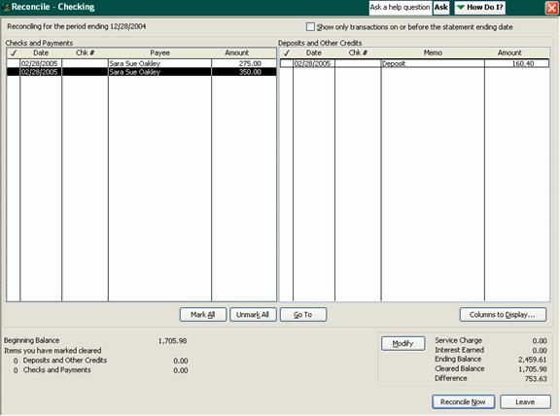
- Compare each check and deposit with the ones listed on your bank statement. Click on each item in QuickBooks as you match it; this places a checkmark next to the item, indicating it will be cleared.
  - If a transaction amount doesn't match the amount shown on your statement, double-click the transaction to open it and make the necessary changes. Then save and close the transaction to return to the Reconcile window.
  - If a transaction shown on your statement is missing entirely from your register, open your register and enter the transaction. Then save and close it to return to the Reconcile window.
- As you clear transactions, QuickBooks calculates the total amount you've cleared against the statement and displays the difference. When the difference is 0.00, click Reconcile Now.
If you finish clearing the transactions and QuickBooks still shows a difference (a discrepancy), then you can either use the methods described above to find and fix the discrepancy, or you can click Reconcile Now to have QuickBooks enter a balance adjustment. If you later find the source of the problem and are able to correct it, you can (and should) delete the balance adjustment transaction from your register.

Adjusting Inventory
Although QuickBooks can automatically update your inventory when items are received and sold, you'll need to manually adjust inventory to account for gains and shrinkage (theft, breakage, etc.):
- From the Vendors menu, select Inventory Activities, and then select Adjust Quantity/Value on Hand from the submenu.
The Adjust Quantity/Value on Hand window opens.
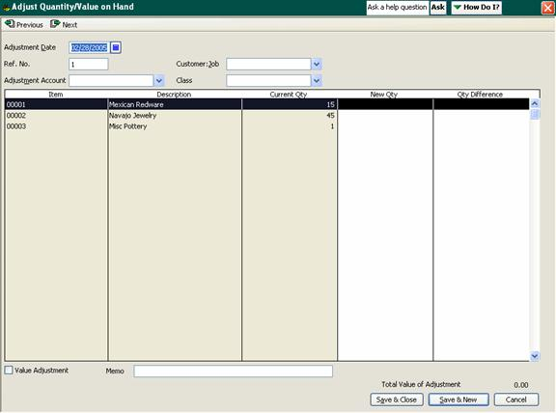
- Confirm the date and enter a reference number (optional).
- Select the adjustment account from the drop-down menu. For losses, this will be an expense account associated with the loss; for gains, it will be an income account.
Note: You should create separate adjustments for each account.
- Select the associated customer and class, as appropriate. This is optional.
- To adjust the quantity of an item in the inventory list, enter the new quantity or the difference in quantity (whichever you prefer) into the appropriate column.
- To update the value of inventory items, select the Value Adjustment checkbox. This displays the New Value column. Enter the new value of the items you're adjusting.
- Click Save & Close to update the inventory.

Creating Reports
You can create a range of reports using the Reports button at the bottom of most of the QuickBooks navigators. You can also select a report using the Report Finder:
- From the navigators list, select Reports.
The Report Finder opens.
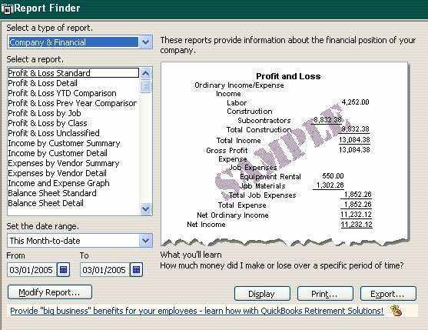
- Select the type of report to view a list of reports in that category. Then select a report from the list. A preview of the report is displayed on the right side of the window.
- Select a date range for the report.
- To customize the report, click the Modify Report button.
This opens the Modify Report dialog, which contains various options for the report you selected. For instance, you can select which columns to include in the report, select filters to limit the data included in the report, change the headers and footers and change the fonts used for column and row labels, data and other elements.
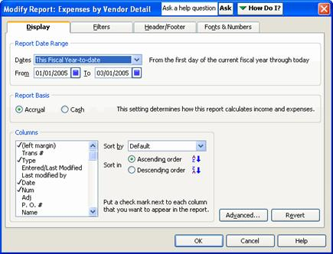
Make your selections and click OK to close the dialog.
- Click Display to view the report in the Report window. Or, click Print to print a hard copy of the report.
Clicking Excel opens the report in Microsoft® Excel.

Closing Your Books for an Accounting Period
When you close your books at the end of an accounting period, you restrict access to transactions from prior accounting periods. To enter a closing date for your books:
- From the Edit menu, select Preferences.
- In the Preferences window, select the Accounting icon from the list on the left.
- Select the Company Preferences tab.
- Under Closing Date, enter the date through which you want your books closed.
- To limit access to the closed period, click the Set Password button.
- In the window that opens, enter a password and click OK.
- Click OK to close the Preferences window.
Historical transactions are still visible, but the password is required in order to modify or delete any of the transactions, as well as to enter new transactions prior to the closing date.

